1st Sunday of Christmas



MOUNT TABOR LUTHERAN CHURCH

December 29, 2024


Welcome to our Service

Our mission at Mount Tabor is to be “an inclusive, compassionate faith community living God’s love in the world.” Mount Tabor is a member of the Evangelical Lutheran Church in America and a Reconciling in Christ congregation of the ELCA. This means that all are welcome and affirmed, especially our LGBTQ+ siblings, and that we are connected to the world. We all have a place here at God’s round table just as we are!

If this is your first time here, a special welcome to you! We are mask optional and mask friendly. Please sign the guest register in the narthex (along with your e-mail and cell) so we can be in touch, put on a name tag and join us for refreshments after the service.

Holy Communion is open to all. Children of all ages are invited to receive communion with their parents’ or guardians’ permission. Come when you are ready. Gluten-free bread is available. If you would like a blessing, come to the altar with your arms folded.

Children are welcome at all times in the sanctuary. We are blessed to be part of their faith formation through worship!

Please turn off cell phones in the sanctuary before worship begins.

You may add names to the prayer list by sending a request to Brenda Wardle (office@mttaborslc.org), or Pastor Christine (pastor@mttaborslc.org). Names added to the prayer list will remain there for one month. You may request that they stay on longer or come off sooner by contacting the same people.

Visit our web site at www.mttaborslc.org

First Sunday of Christmas
December 29, 2024
ELW Service Music
*Please rise as you are able

Greeting & Preparation for Worship

Gathering
The Holy Spirit Calls Us Together as the People of God.

Prelude David Kime

*Call to Worship

We know that joy… what are some of the things that bring you joy? Yell it out!
After a few moments of sharing the presiding minister begins the litany.
We have named our joy out loud, and it is clear—
God is in our joy.
God is in this room.
We have reason to celebrate.
We have a reason to sing.
Thanks be to God for the bright hope of this day.

Gathering Song Joyful, Joyful We Adore Thee #836

Confession and Absolution

All may make the sign of the cross, the sign that is marked at baptism, as the presiding minister begins.

Friends, one of the most inherently joyful and beautiful moments in worship comes through the moment of confession. For when we are honest with God in the prayer of confession, we open ourselves up to receive God’s grace and mercy. And that gift—that grace—is full to the brim with good news!
So join me in this prayer of confession, not out of shame or guilt, but because there is a joy on the other side of this prayer that will take your breath away.
Let us pray together; let us choose joy. Let us come in truth before the One who loves us and has freed us from our sin.

Silence is kept for reflection.

Joyful God,
You told us that in order to enter the kingdom of heaven, we must be like children.
Did you mean that like children, we must practice unhindered joy?
Did you mean that like children, we should lean into laughter, release our cynicism, and open ourselves to delight?
In a world as broken and battered as ours, we admit,
this often seems easier said than done.
Forgive us, patient God, for the moments when we are so focused on the bad that we miss the good.
Forgive us for hearing the nativity story and staying in our seats
instead of jumping for joy.
We know that even now you are sowing delight in our lives.
Open our hearts up to it, with gratitude we pray.
Amen.

Friends, hear and believe the good news of the Gospel:
We are seen. We are loved. We are forgiven.
That is news worth celebrating! That is news that should make us want to cheer, laugh, cry with relief, dance, and sing all at the same time! So, in response to God’s goodness, I invite you to join me in the sung response. Let us make a joyful noise for God’s abundant mercy.
Amen.

Song of Joy I’ve Got the Joy, Joy, Joy TFF # 257

Greeting
The grace of our Lord Jesus Christ, the love of God, and the communion of the
Holy Spirit be with you all.
And also, with you.

Prayer of the Day
God of angel choruses and contagious laughter,
we know that you speak to us in the quiet.
We know that when we bow our heads and fall to our knees,
you are there, hovering close, calling our names.
However, we also trust that when we throw our heads back in laughter,
when we dance and clap with joy, when we skip and sing with gratitude,
that even there, you are speaking.
So, on this Sunday morning we pray:
open our ears and hearts to hear what it is that you are saying.
Meet us in this joy. Meet us in this delight.
Meet us in the hope of this Christmas season
and reveal the wisdom we need to hear today.
With hearts full of gratitude we pray.
We laugh. We listen. We pray.
Amen.
Please be seated.

The Word
God Speaks to Us in Scripture Reading, Preaching and Song.

Listen for Joy 1 Samuel 2:18-20, 26
¹⁸ Samuel was ministering before the Lord, a boy wearing a linen ephod. ¹⁹ His mother used to make for him a little robe and take it to him each year, when she went up with her husband to offer the yearly sacrifice. ²⁰ Then Eli would bless Elkanah and his wife, and say, “May the Lord repay you with children by this woman for the gift that she made to the Lord”; and then they would return to their home. ²⁶ Now the boy Samuel continued to grow both in stature and in favor with the Lord and with the people.

Word of God, word of life.
Thanks be to God.

Song of Joy Go Tell It on the Mountain #290

Listen for Joy Colossians 3:12-17
¹² As God’s chosen ones, holy and beloved, clothe yourselves with compassion, kindness, humility, meekness, and patience. ¹³ Bear with one another and, if anyone has a complaint against another, forgive each other; just as the Lord has forgiven you, so you also must forgive. ¹⁴ Above all, clothe yourselves with love, which binds everything together in perfect harmony. ¹⁵ And let the peace of Christ rule in your hearts, to which indeed you were called in the one body. And be thankful. ¹⁶ Let the word of Christ dwell in you richly; teach and admonish one another in all wisdom; and with gratitude in your hearts sing psalms, hymns, and spiritual songs to God. ¹⁷ And whatever you do, in word or deed, do everything in the name of the Lord Jesus, giving thanks to God the Father through him.

Word of God, word of life.
Thanks be to God.

*Gospel Acclamation - ACS #12
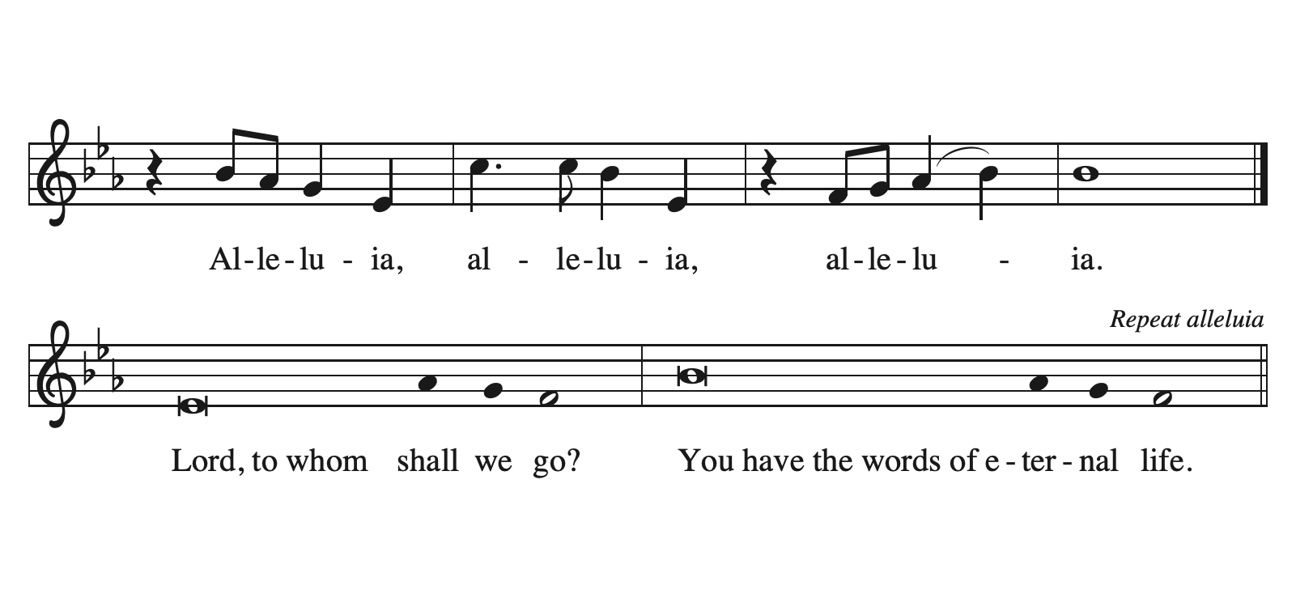

The Gospel

The Holy Gospel according to Luke.
Glory to you, O Lord

Luke 2:41-52
⁴¹ Now every year [Jesus’] parents went to Jerusalem for the festival of the Passover. ⁴² And when he was twelve years old, they went up as usual for the festival. ⁴³ When the festival was ended and they started to return, the boy Jesus stayed behind in Jerusalem, but his parents did not know it. ⁴⁴ Assuming that he was in the group of travelers, they went a day’s journey. Then they started to look for him among their relatives and friends. ⁴⁵ When they did not find him, they returned to Jerusalem to search for him. ⁴⁶ After three days they found him in the temple, sitting among the teachers, listening to them and asking them questions. ⁴⁷ And all who heard him were amazed at his understanding and his answers. ⁴⁸ When his parents saw him they were astonished; and his mother said to him, “Child, why have you treated us like this? Look, your father and I have been searching for you in great anxiety.” ⁴⁹ He said to them, “Why were you searching for me? Did you not know that I must be in my Father’s house?” ⁵⁰ But they did not understand what he said to them. ⁵¹ Then he went down with them and came to Nazareth, and was obedient to them. His mother treasured all these things in her heart. ⁵² And Jesus increased in wisdom and in years, and in divine and human favor.

The Gospel of the Lord.
Praise to you, O Christ.

Message Pastor Christine Higueria-Street
A time of silence follows the sermon for reflection on the message.

*Hymn of the Day Let’s All Together Praise Our God #287

The Prayers of the People
Please be seated.

Filled with good news of great joy, let us offer our prayers for the church, the earth, and all people.

After each petition
God of Grace,
receive our prayer.

We remember in prayer. . . . . .
Vicki Lange Doug Kempf
Tonya Aston Ben Roundy
Jan Burke Shannon Wardle
Paul Robinson Brett Wardle
Travis and Nathan Jelsma-Beery Toby Goldsmith
Rosemary Stelz
The people of Ukraine, South Sudan, Israel, Gaza and the West Bank

We pray for all those suffering the effects of traumatic events, natural disasters and climate change. We pray for the recovery efforts, the first responders and volunteers who are serving in these areas.

We commend these prayers to you, O God, trusting your grace made known to all, through the Word made flesh, Jesus Christ, our Savior and Lord.
Amen.

Practice Joy
When the Magi are traveling…. Friends, the peace and joy of Christ be with you.
And also with you.
Let us pass signs of joy and peace to one another.

Meal
God Feeds Us with the Presence of Jesus Christ.

Sharing our Gifts and Gratitude

We provide several ways of sharing your financial blessings with our congregation. Offering plates are located at the doors of the sanctuary and envelopes can be found in the pews. Simply Giving is an automatic direct-donation method of supporting our life and ministry together. If you would like to enroll in Simply Giving or if you are interested in updating your giving amount, frequency, etc., please contact office@mttaborslc.org with your request. We are grateful and thankful for your support and wonderful generosity. Alternately, feel free to use this QR code to contribute electronically.

Prayer of Gratitude
Let us pray,
God of heaven and earth, from the beginning, you have called forth life, in which you take delight. The trees, the fields, and the seas sing for joy. Bless now these gifts, received from your bounty, that we may join the chorus of creation to tell of your salvation from day to day.
Amen.

Great Thanksgiving
The table is prepared as the assembly sings:

Lamb of God #198
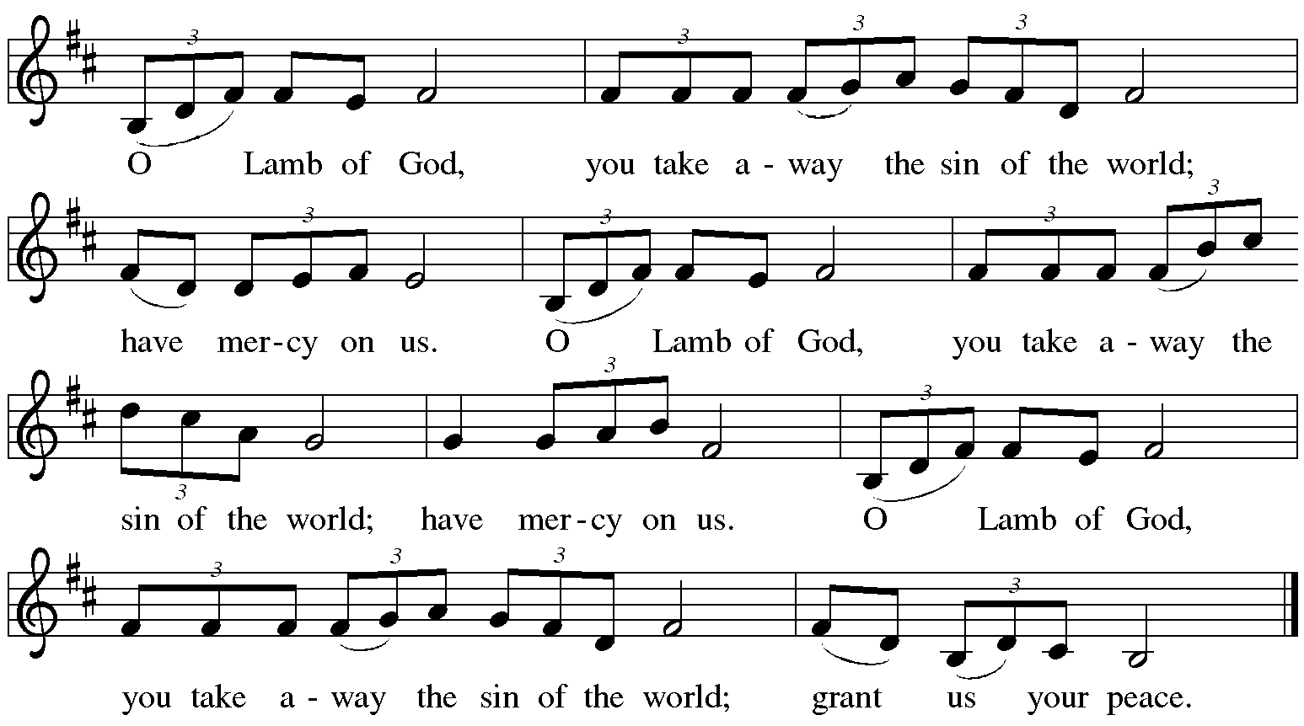

*Dialogue

The Lord be with you.
And also with you.

Lift up your hearts.
We lift them to the Lord.

Let us give thanks to the Lord our God.
It is right to give our thanks and praise.

Table Prayer

Holy God . . . in your holy Church, both now and forever.
Amen
Holy, Holy, Holy #191
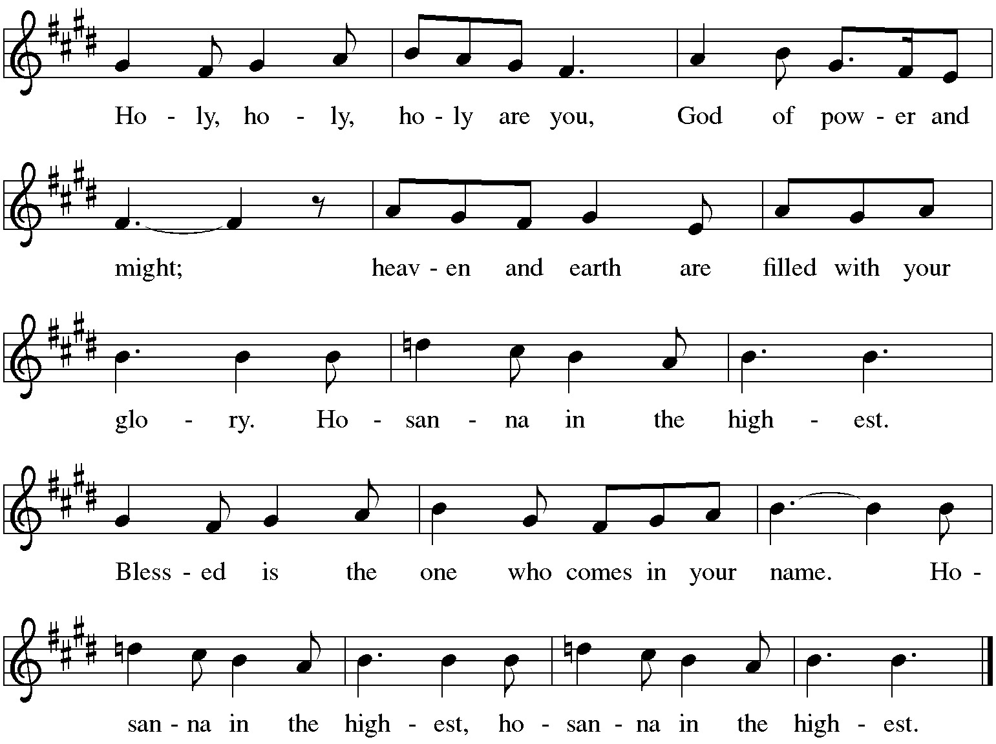

The Words of Institution

In the night…. in your holy Church, both now and forever.
Amen.

Lord's Prayer

We joyfully celebrate God with us and pray:

Our Father in heaven,
hallowed be your name,
your kingdom come,
your will be done,
on earth as in heaven.
Give us today our daily bread.
Forgive us our sins
as we forgive those
who sin against us.
Save us from the time of trial
and deliver us from evil.
For the kingdom, the power,
and the glory are yours,
now and forever. Amen.

Invitation to Communion

The Distribution Come when you are ready, children are always welcome!

Communion Songs

What Child is This? #296
Infant Holy, Infant Lowly # 276

*Post Communion Blessing

Prayer After Communion

Let us pray.
Merciful God, we thank you for Jesus, who is our heavenly food. Strengthened by this goodness, send us forth to announce your peace, comfort the afflicted, and share the good news of great joy.
Amen.
Please be seated.

Sending
God Blesses Us and Sends Us in Mission to the World.

Our Life Together (pg.)

*Blessing

Family of faith, in a hurting and lonely world,
in a battered and bruised society, there is good news:
Jesus Christ is born! So as you leave this place,
may you be quick to laugh and quick to hope.
May you look for reasons to be grateful.
May you not hesitate to join in the dance, or join in the song.
May you extend a hand to your neighbor, and find God in every moment of
joy. For unto you a child is born. That is good news!
Amen.

Sending Song Cold December Flies Away #299

Dismissal

Go in peace trusting in God’s promises.
Go in peace and go with joy.
Thanks be to God.

Postlude David Kime

Copyright © 2024 Augsburg Fortress. All rights reserved. Reprinted by permission under Augsburg Fortress Liturgies Annual License #SAS003548. Expires 9/30/2024 Annual License with Podcasting, OneLicense #A-720902. Expires June 17, 2025.New Revised Standard Version Bible, copyright © 1989, Division of Christian Education of the National Council of the Churches of Christ in the United States of America. Used by permission. All rights reserved. Revised Common Lectionary, Copyright © 1992 Consultation on Common Texts, admin Augsburg Fortress. Used by permission. Adapted from a prayer by Rev. Sarah A. Speed |A Sanctified Art LLC | Sanctifiedart.org.

December 29, 2024 1st Sunday of Christmas

Assisting Minister: Lawrence Allred

Lector: Chris Jensen

Counters: Virginia Hancock, Dave Warren
Usher: Sarah Lange
Altar Ministry:
Music Director: Bob Brown
AV Technicians: Duane Lee
Remote Office Assistant: Brenda Wardle
Presiding Minister: Rev. Christine Higueria-Street

Our Life Together Announcements

Transition Listening Circles - please sign up for one of the listening circles in January. The signup sheets are available after worship from the Transition team members; Dannie, Lanea, or Radek. Remember, it is one time, one hour.

Curious About Joy – A Women’s Christmas Retreat Saturday, January 11, 2025 10 a.m. – 1 p.m.at Mt. Tabor Lutheran Church. The registration fee for this retreat is $25. Scholarships are available. Please let Pastor DanaLee know if you are in need of one. Please register and reserve your spot by e-mailing DanaLee and letting her know you will be attending. Include your name, phone number and congregation. Her e-mail address is sagehillwisdom@gmail.com. For more information please see our website at www.mttaborslc.org or talk to Jean Stephenson.

Epiphany Bible Study - will begin on Sunday, January 19th immediately following worship during the coffee hour. Please let Pastor Christine know if you are interested so that we have enough materials for everyone.

Annual reports need to be to Brenda no later than January 19th. So that they can be out two weeks before the annual meeting as the by-laws state

Annual Meeting - Mark your calendars for February 9th immediately following worship.

Pastor Christine is available by text or email. Her contact information is pastor@mttaborslc.org or 801-215-9208

