Fourth Sunday after Epiphany


MOUNT TABOR LUTHERAN CHURCH

February 2, 2025


Welcome to our Service

Our mission at Mount Tabor is to be “an inclusive, compassionate faith community living God’s love in the world.” Mount Tabor is a member of the Evangelical Lutheran Church in America and a Reconciling in Christ congregation of the ELCA. This means that all are welcome and affirmed, especially our LGBTQ+ siblings, and that we are connected to the world. We all have a place here at God’s round table just as we are!

If this is your first time here, a special welcome to you! We are mask optional and mask friendly. Please sign the guest register in the narthex (along with your e-mail and cell) so we can be in touch, put on a name tag and join us for refreshments after the service.

Holy Communion is open to all. Children of all ages are invited to receive communion with their parents’ or guardians’ permission. Come when you are ready. Gluten-free bread is available. If you would like a blessing, come to the altar with your arms folded.

Children are welcome at all times in the sanctuary. We are blessed to be part of their faith formation through worship!

Please turn off cell phones in the sanctuary before worship begins.

You may add names to the prayer list by sending a request to Brenda Wardle (office@mttaborslc.org), or Pastor Christine (pastor@mttaborslc.org). Names added to the prayer list will remain there for one month. You may request that they stay on longer or come off sooner by contacting the same people.

Visit our web site at www.mttaborslc.org

Fourth Sunday after Epiphany
ELW Setting Ten
Please rise as you are able

Greeting & Preparation for Worship

Gathering
The Holy Spirit Calls Us Together as the People of God.

Prelude Bob Brown

Confession and Absolution
All may make the sign of the cross, the sign that is marked at baptism, as the presiding minister begins.

Blessed be the holy Trinity, ☩ one God,
our creator,
our protector,
our wellspring of life.
Amen.

Trusting that God receives our words and the meditations of our hearts, let us confess our sin.

Silence is kept for reflection.

Merciful God, you speak blessing and compassion into the world. Forgive us for the ways we act with judgment, cruelty, or indifference. We ignore the needs of our neighbors; we resist your call to oppose injustice; we give in to scarcity and fear; we assume the worst about one another. Cleanse us from our faults and release us from their grasp. Show us your loving kindness. Restore our hearts and repair your world, that we may live in Christ’s ways.
Amen.

God proclaims these words of assurance: “Do not fear, for I have redeemed you. I have called you by name. You are mine.” In ☩ Christ, you are forgiven. In the Spirit, you are made free. Refreshed by the waters of mercy, live anew as beloved children of God.
Amen.

Gathering Song 4x’s ACS #978
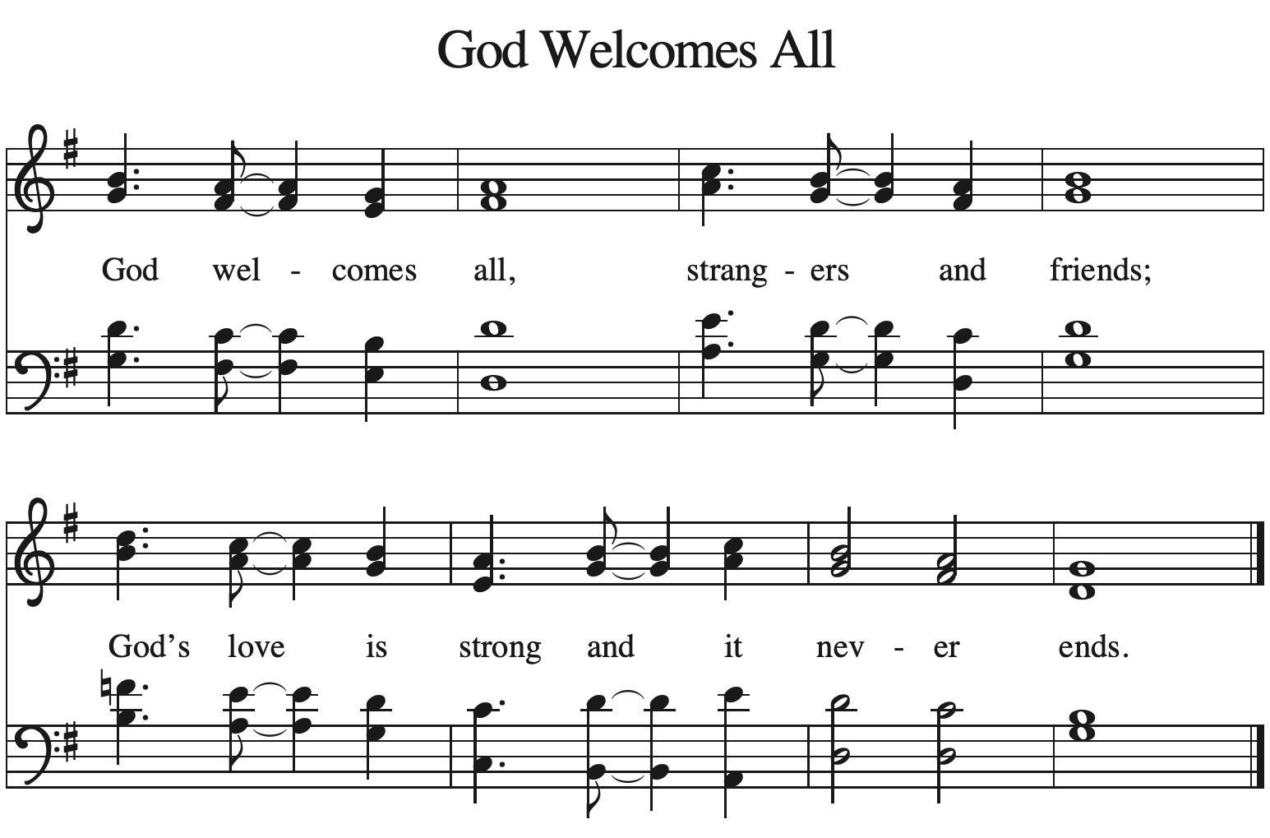
Greeting
The grace of our Lord Jesus Christ, the love of God, and the communion of the
Holy Spirit be with you all.
And also, with you.

Kyrie
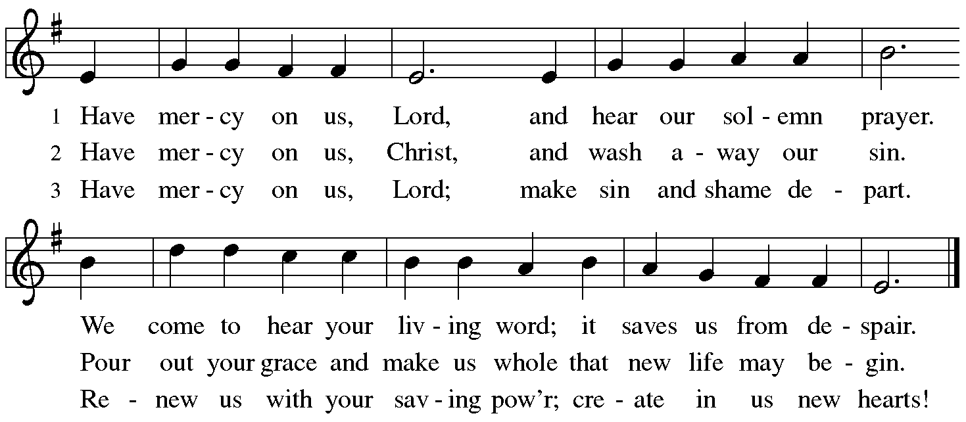

Song of Praise
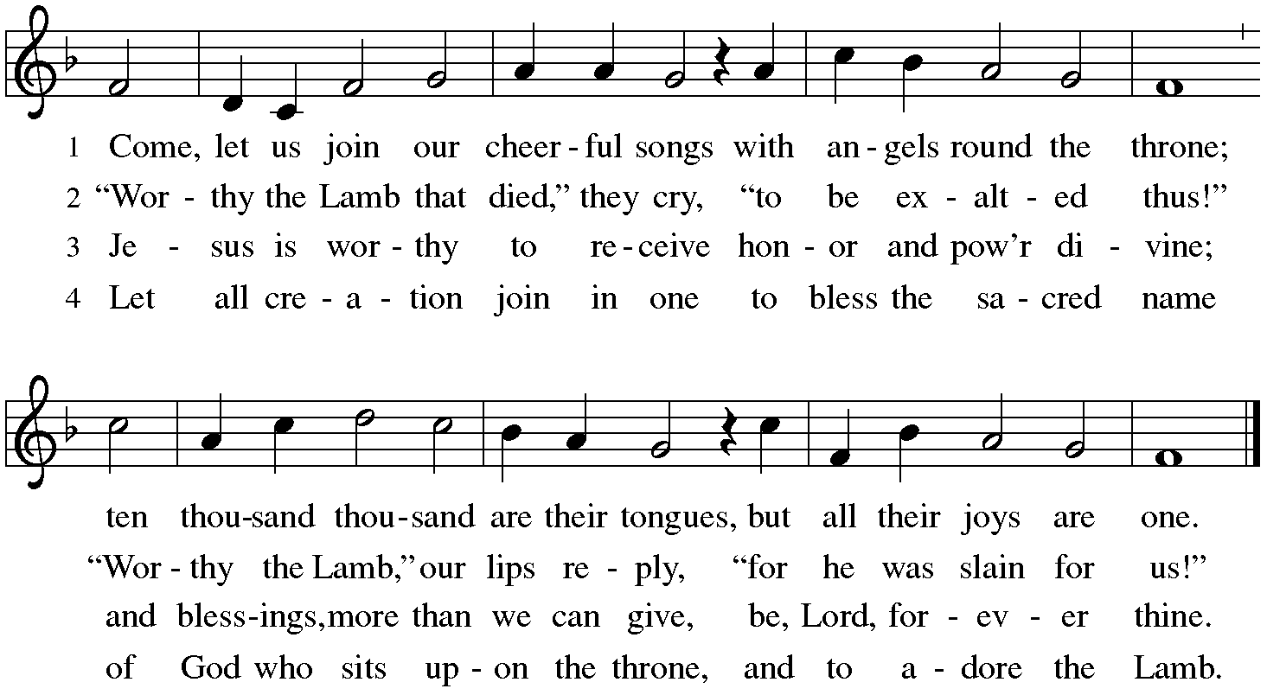

Prayer of the Day
Almighty and ever-living God, increase in us the gifts of faith, hope, and love; and that we may obtain what you promise, make us love what you command, through your Son, Jesus Christ, our Savior and Lord.
Amen.
Please be seated.

The Word
God Speaks to Us in Scripture Reading, Preaching and Song

First Reading Jeremiah 1:4-10

⁴ Now the word of the Lord came to me saying, ⁵ “Before I formed you in the womb I knew you, and before you were born I consecrated you; I appointed you a prophet to the nations.” ⁶ Then I said, “Ah, Lord God! Truly I do not know how to speak, for I am only a boy.” ⁷ But the Lord said to me, “Do not say, ‘I am only a boy’; for you shall go to all to whom I send you, and you shall speak whatever I command you. ⁸ Do not be afraid of them, for I am with you to deliver you, says the Lord.” ⁹ Then the Lord put out his hand and touched my mouth; and the Lord said to me, “Now I have put my words in your mouth.¹⁰ See, today I appoint you over nations and over kingdoms, to pluck up and to pull down,
to destroy and to overthrow, to build and to plant.”

Word of God, word of life.
Thanks be to God.

Special Music Jesu, Word of God Incarnate Mozart
Sue Phay, Mallory deForest, Lee Kreutzer, Stephanie Wilson
Vocalists

Second Reading 1 Corinthians 13:1-13
¹ If I speak in the tongues of mortals and of angels, but do not have love, I am a noisy gong or a clanging cymbal. ² And if I have prophetic powers, and understand all mysteries and all knowledge, and if I have all faith, so as to remove mountains, but do not have love, I am nothing. ³ If I give away all my possessions, and if I hand over my body so that I may boast, but do not have love, I gain nothing. ⁴ Love is patient; love is kind; love is not envious or boastful or arrogant ⁵ or rude. It does not insist on its own way; it is not irritable or resentful; ⁶ it does not rejoice in wrongdoing, but rejoices in the truth. ⁷ It bears all things, believes all things, hopes all things, endures all things. ⁸ Love never ends. But as for prophecies, they will come to an end; as for tongues, they will cease; as for knowledge, it will come to an end. ⁹ For we know only in part, and we prophesy only in part; ¹⁰ but when the complete comes, the partial will come to an end. ¹¹ When I was a child, I spoke like a child, I thought like a child, I reasoned like a child; when I became an adult, I put an end to childish ways. ¹² For now we see in a mirror, dimly, but then we will see face to face. Now I know only in part; then I will know fully, even as I have been fully known. ¹³ And now faith, hope, and love abide, these three; and the greatest of these is love.

Word of God, word of life.
Thanks be to God.

Gospel Acclamation

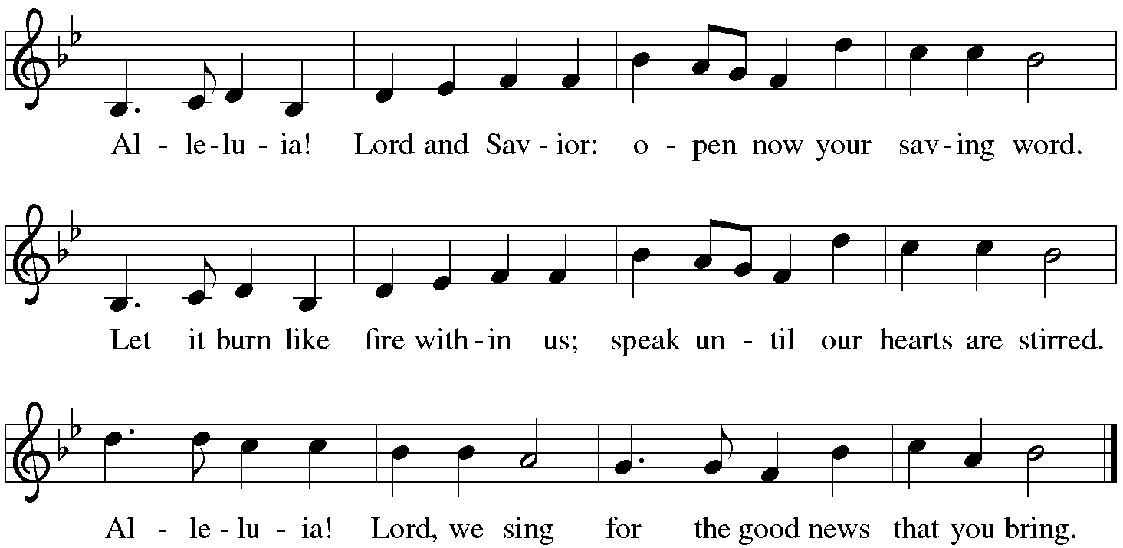

The Gospel

The Holy Gospel according to Luke.
Glory to you, O Lord.

. Luke 4:21-30
²¹ Then [Jesus] began to say to [all in the synagogue in Nazareth,] “Today this scripture has been fulfilled in your hearing.” ²² All spoke well of him and were amazed at the gracious words that came from his mouth. They said, “Is not this Joseph’s son?” ²³ He said to them, “Doubtless you will quote to me this proverb, ‘Doctor, cure yourself!’ And you will say, ‘Do here also in your hometown the things that we have heard you did at Capernaum.’ ” ²⁴ And he said, “Truly I tell you, no prophet is accepted in the prophet’s hometown. ²⁵ But the truth is, there were many widows in Israel in the time of Elijah, when the heaven was shut up three years and six months, and there was a severe famine over all the land; ²⁶ yet Elijah was sent to none of them except to a widow at Zarephath in Sidon. ²⁷ There were also many lepers in Israel in the time of the prophet Elisha, and none of them was cleansed except Naaman the Syrian.” ²⁸ When they heard this, all in the synagogue were filled with rage. ²⁹ They got up, drove him out of the town, and led him to the brow of the hill on which their town was built, so that they might hurl him off the cliff. ³⁰ But he passed through the midst of them and went on his way.

The Gospel of the Lord.
Praise to you, O Christ.

Message Pastor Christine Higueria-Street
A time of silence follows the sermon for reflection on the message.

*Hymn of the Day He Comes to Us as One Unknown #737

The Prayers of the People
Please be seated.

With the Spirit of Christ shining upon us, let us boldly pray for the church, the world, and all of creation.

After each petition
God of Grace,
hear our prayer.

We remember in prayer. . . . . .
Vicki Lange Doug Kempf
Tonya Aston Ben Roundy
Jan Burke Toby Goldsmith
Paul Robinson Mike Street
Travis and Nathan Jelsma-Beery Dannie Gavros
Rosemary Stelz Tonya Ashton
Scott Larrabee Hannah Comb
Leonard The Wardle Family
We pray for all those suffering the effects of traumatic events, natural disasters and climate change. We pray for the recovery efforts, the first responders and volunteers who are serving in these areas.

We entrust our prayers to you, O God, in the sure and certain hope that your promise is revealed among the people.
Amen

Sharing the Peace
The peace of Christ be with you always.
And also with you.

Meal
God Feeds Us with the Presence of Jesus Christ.

Sharing our Gifts and Gratitude

We provide several ways of sharing your financial blessings with our congregation. Offering plates are located at the doors of the sanctuary and envelopes can be found in the pews. Simply Giving is an automatic direct-donation method of supporting our life and ministry together. If you would like to enroll in Simply Giving or if you are interested in updating your giving amount, frequency, etc., please contact office@mttaborslc.org with your request. We are grateful and thankful for your support and wonderful generosity. Alternately, feel free to use this QR code to contribute electronically.


Prayer of Gratitude
Let us pray,
God of grace, your love reaches to the heavens, and your abundance to the depths of the seas. Bless what we offer to your service: our gifts, our abilities, and our hearts. Let us overflow with gratitude and generosity, now and always.
Amen.

Great Thanksgiving
The table is prepared as the assembly sings:

Lamb of God
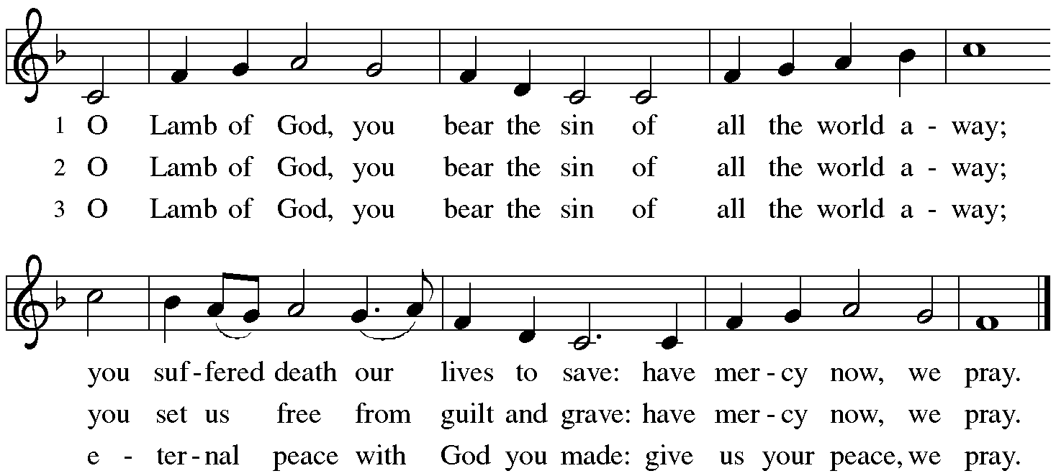

*Dialogue

The Lord be with you.
And also with you.

Lift up your hearts.
We lift them to the Lord.

Let us give thanks to the Lord our God.
It is right to give our thanks and praise.

Table Prayer

Holy God . . . and together with the heavenly host we praise your name.
Amen

Holy, Holy, Holy
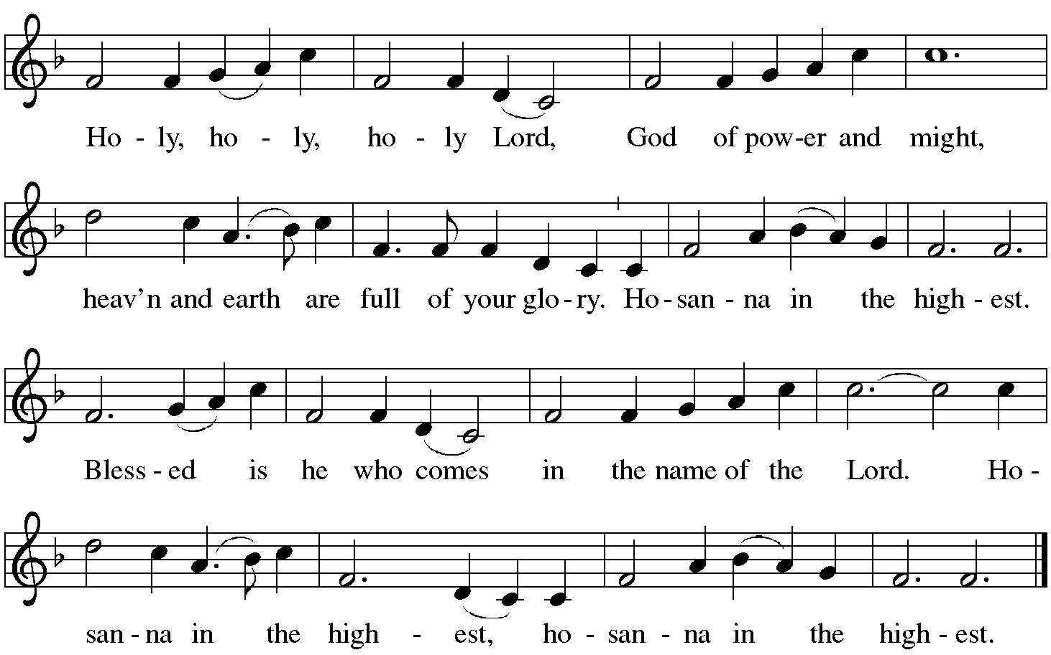

The Words of Institution

In the night…. in your holy Church, both now and forever.
Amen.

Lord's Prayer

As children of your light, we pray:

Eternal Spirit, Father and Mother of us all, Holy is your name. Let justice and mercy fill all Creation and let us recognize that every thought and thing belongs to you. Feed us with the bread we need for today. Forgive our sin as we forgive those who sin against us. Stand with us in trial and temptation. Free us from the grip of all that is evil. For you alone are creating our universe, now and forever. Amen.¹

Invitation to Communion

The Distribution Come when you are ready, children are always welcome!

Communion Songs

Love Divine, All Loves Excelling #631
As the Grains of Wheat #406

*Post Communion Blessing

Prayer After Communion

Let us pray.
Nourishing God,
at this table you have refreshed us with holy gifts of food and drink. Strengthen us for service and send us out to embody your good news of liberation and healing for the sake of the world. In the name of Christ, we pray.
Amen.
Please be seated.

Sending
God Blesses Us and Sends Us in Mission to the World.

Our Life Together (pg.16)

*Blessing

The Spirit of the triune God
☩ bless you with joy,
anoint you with compassion,
and send you in love.
Amen.

Sending Song TTF #259

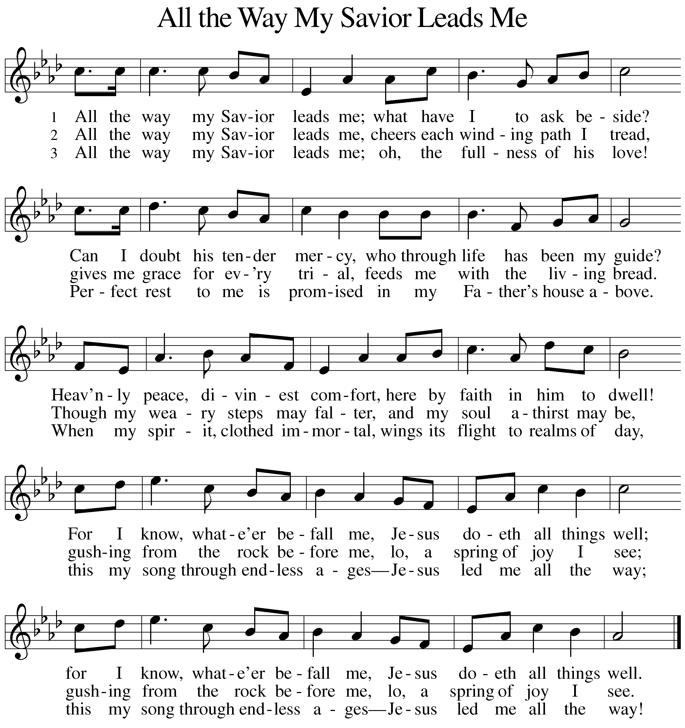

Dismissal

Go in peace. Live in hope.
Thanks be to God.

Postlude Bob Brown

Copyright © 2024 Augsburg Fortress. All rights reserved. Reprinted by permission under Augsburg Fortress Liturgies Annual License #SAS003548. Expires 9/30/2025 Annual License with Podcasting, OneLicense #A-720902. Expires June 17, 2025.New Revised Standard Version Bible, copyright © 1989, Division of Christian Education of the National Council of the Churches of Christ in the United States of America. Used by permission. All rights reserved. Revised Common Lectionary, Copyright © 1992 Consultation on Common Texts, admin Augsburg Fortress. https://sandhyajha.com/2013/07/01/variations-on-the-lords-prayer/

Fourth Sunday after Epiphany: February 2, 2025

Assisting Minister: Jenny Jensen
Lector: Dan Wall

Counters: Virginia Hancock, Sarah Lange
Usher: Deng Hoth
Altar Ministry: Becki Kaiser
Music Director: Bob Brown
AV Technicians: Duane Lee, Lee Kreutzer
Remote Office Assistant: Brenda Wardle
Presiding Minister: Rev. Christine Higueria-Street

Our Life Together Announcements

Transition Listening Circles – last chance to participate in the listening circles is today after worship. Check with our Transition team members; Dannie, David, Lanea, or Radek. Remember, it is one time, one hour.

Epiphany Bible Study – continues immediately following worship during the coffee hour.

Worship and Music Ministry – meets today after worship.

Annual Meeting is next Sunday, February 9th immediately following worship. Please plan to attend.

Family Promise Service Opportunity - Mt. Tabor has been presented with an opportunity to provide dinners for Family Promise February 16,17,19, 21, and a brunch on Saturday 22 and again with dinners February 23, 24, 26, 28, and a brunch March 1. All these meals will be provided at the host congregation site of Christ United Methodist Church 2375 E 3300 S. More details at to numbers and special dietary needs will be provided as the dates get
closer. This is a great opportunity to share God’s love with families needing some extra support. If you can provide a meal on any of
those dates, please let me know.
Chris Jensen

Please join us on Sunday, February 23 after service for a celebration of love! We will honor two couples: one who was recently married, David and Angela; and one who will be married this spring, Virginia and Will. It’s sure to be a joyful event!
Pastor Christine is available by text or email. Her contact information is pastor@mttaborslc.org or 801-215-9208

