Second Sunday after Epiphany


MOUNT TABOR LUTHERAN CHURCH

January 19, 2025


Welcome to our Service

Our mission at Mount Tabor is to be “an inclusive, compassionate faith community living God’s love in the world.” Mount Tabor is a member of the Evangelical Lutheran Church in America and a Reconciling in Christ congregation of the ELCA. This means that all are welcome and affirmed, especially our LGBTQ+ siblings, and that we are connected to the world. We all have a place here at God’s round table just as we are!

If this is your first time here, a special welcome to you! We are mask optional and mask friendly. Please sign the guest register in the narthex (along with your e-mail and cell) so we can be in touch, put on a name tag and join us for refreshments after the service.

Holy Communion is open to all. Children of all ages are invited to receive communion with their parents’ or guardians’ permission. Come when you are ready. Gluten-free bread is available. If you would like a blessing, come to the altar with your arms folded.

Children are welcome at all times in the sanctuary. We are blessed to be part of their faith formation through worship!

Please turn off cell phones in the sanctuary before worship begins.

You may add names to the prayer list by sending a request to Brenda Wardle (office@mttaborslc.org), or Pastor Christine (pastor@mttaborslc.org). Names added to the prayer list will remain there for one month. You may request that they stay on longer or come off sooner by contacting the same people.

Visit our web site at www.mttaborslc.org

Second Sunday after Epiphany
ELW Setting Ten
*Please rise as you are able

Greeting & Preparation for Worship

Gathering
The Holy Spirit Calls Us Together as the People of God.

Prelude Bob Brown

Confession and Absolution
All may make the sign of the cross, the sign that is marked at baptism, as the presiding minister begins.

Blessed be the holy Trinity, ☩ one God,
our creator,
our protector,
our wellspring of life.
Amen.

Trusting that God receives our words and the meditations of our hearts, let us confess our sin.

Silence is kept for reflection.

Merciful God, you speak blessing and compassion into the world. Forgive us for the ways we act with judgment, cruelty, or indifference. We ignore the needs of our neighbors; we resist your call to oppose injustice; we give in to scarcity and fear; we assume the worst about one another. Cleanse us from our faults and release us from their grasp. Show us your loving kindness. Restore our hearts and repair your world, that we may live in Christ’s ways.
Amen.

God proclaims these words of assurance: “Do not fear, for I have redeemed you. I have called you by name. You are mine.” In ☩ Christ, you are forgiven. In the Spirit, you are made free. Refreshed by the waters of mercy, live anew as beloved children of God.
Amen.

Gathering Song All Are Welcome #641

Greeting
The grace of our Lord Jesus Christ, the love of God, and the communion of the
Holy Spirit be with you all.
And also, with you.

Kyrie
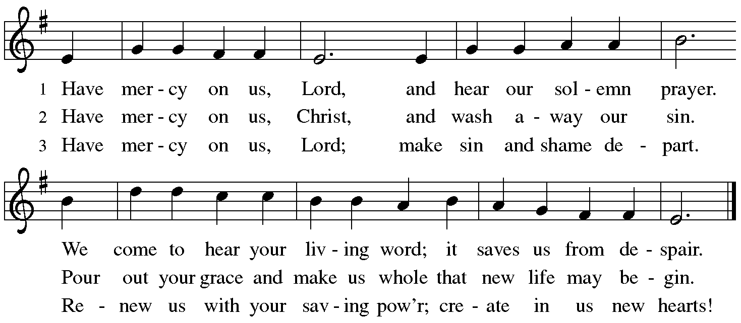
Song of Praise
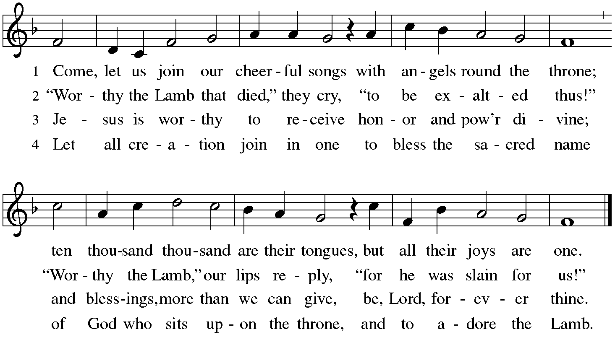

Prayer of the Day
Lord God, source of every blessing, you showed forth your glory and led many to faith by the works of your Son, who brought gladness and salvation to his people. Transform us by the Spirit of his love, that we may find our life together in him, Jesus Christ, our Savior and Lord.
Amen.
Please be seated.

The Word
God Speaks to Us in Scripture Reading, Preaching and Song

First Reading Isaiah 62:1-5

¹ For Zion’s sake I will not keep silent, and for Jerusalem’s sake I will not rest, until her vindication shines out like the dawn, and her salvation like a burning torch.² The nations shall see your vindication, and all the kings your glory; and you shall be called by a new name that the mouth of the Lord will give. ³ You shall be a crown of beauty in the hand of the Lord, and a royal diadem in the hand of your God. ⁴ You shall no more be termed Forsaken, and your land shall no more be termed Desolate; but you shall be called My Delight Is in Her, and your land Married; for the Lord delights in you, and your land shall be married.
⁵ For as a young man marries a young woman, so shall your builder marry you,
and as the bridegroom rejoices over the bride, so shall your God rejoice over you.

Word of God, word of life.
Thanks be to God.

Special Music Like As The Hart by Vincent Novello,
Vocalists; Jenny Jensen, Lee Kreutzer

Psalm 36:5-10 (to be read responsively)

⁵ Your love, O Lord, reaches | to the heavens,
and your faithfulness| to the clouds.
⁶ Your righteousness is like the strong mountains, your justice like | the great deep; you save humankind and ani- | mals, O Lord.

⁷ How priceless is your | love, O God!
All people take refuge under the shadow | of your wings.
⁸ They feast upon the abundance | of your house;
you give them drink from the river of | your delights.
⁹ For with you is the | well of life,
and in your light | we see light.
¹⁰ Continue your lovingkindness to | those who know you,
and your favor to those who are | true of heart.

Gospel Acclamation

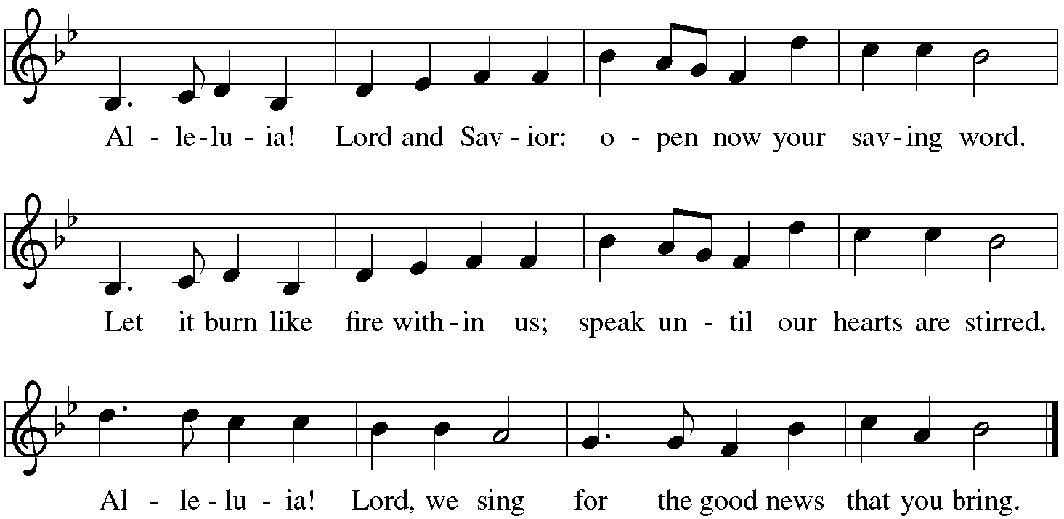

The Gospel

The Holy Gospel according to John.
Glory to you, O Lord

. John 2:1-11
¹ On the third day there was a wedding in Cana of Galilee, and the mother of Jesus was there. ² Jesus and his disciples had also been invited to the wedding. ³ When the wine gave out, the mother of Jesus said to him, “They have no wine.” ⁴ And Jesus said to her, “Woman, what concern is that to you and to me? My hour has not yet come.” ⁵ His mother said to the servants, “Do whatever he tells you.” ⁶ Now standing there were six stone water jars for the Jewish rites of purification, each holding twenty or thirty gallons. ⁷ Jesus said to them, “Fill the jars with water.” And they filled them up to the brim. ⁸ He said to them, “Now draw some out, and take it to the chief steward.” So they took it. ⁹ When the steward tasted the water that had become wine, and did not know where it came from (though the servants who had drawn the water knew), the steward called the bridegroom ¹⁰ and said to him, “Everyone serves the good wine first, and then the inferior wine after the guests have become drunk. But you have kept the good wine until now.” ¹¹ Jesus did this, the first of his signs, in Cana of Galilee, and revealed his glory; and his disciples believed in him.

The Gospel of the Lord.
Praise to you, O Christ.

Message Pastor Christine Higueria-Street
A time of silence follows the sermon for reflection on the message.

*Hymn of the Day Soul, Adorn Yourself with Gladness #488

The Prayers of the People
Please be seated.

With the Spirit of Christ shining upon us, let us boldly pray for the church, the world, and all of creation.

After each petition
God of Grace,
hear our prayer.

We remember in prayer. . . . . .
Vicki Lange Doug Kempf
Tonya Aston Ben Roundy
Jan Burke Toby Goldsmith
Paul Robinson Rosemary Stelz
Travis and Nathan Jelsma-Beery Dannie Gavros
Mike Street Tonya Ashton
Hannah Comb

We pray for all those suffering the effects of traumatic events, natural and climate change. We pray for the recovery efforts, the first responders and volunteers who are serving in these areas.

We entrust our prayers to you, O God, in the sure and certain hope that your promise is revealed among the people.
Amen

Sharing the Peace
The peace of Christ be with you always.
And also with you.

Meal
God Feeds Us with the Presence of Jesus Christ.

Sharing our Gifts and Gratitude

We provide several ways of sharing your financial blessings with our congregation. Offering plates are located at the doors of the sanctuary and envelopes can be found in the pews. Simply Giving is an automatic direct-donation method of supporting our life and ministry together. If you would like to enroll in Simply Giving or if you are interested in updating your giving amount, frequency, etc., please contact office@mttaborslc.org with your request. We are grateful and thankful for your support and wonderful generosity. Alternately, feel free to use this QR code to contribute electronically.


Prayer of Gratitude
Let us pray,
God of grace, your love reaches to the heavens, and your abundance to the depths of the seas. Bless what we offer to your service: our gifts, our abilities, and our hearts. Let us overflow with gratitude and generosity, now and always.
Amen.

Great Thanksgiving
The table is prepared as the assembly sings:

Lamb of God
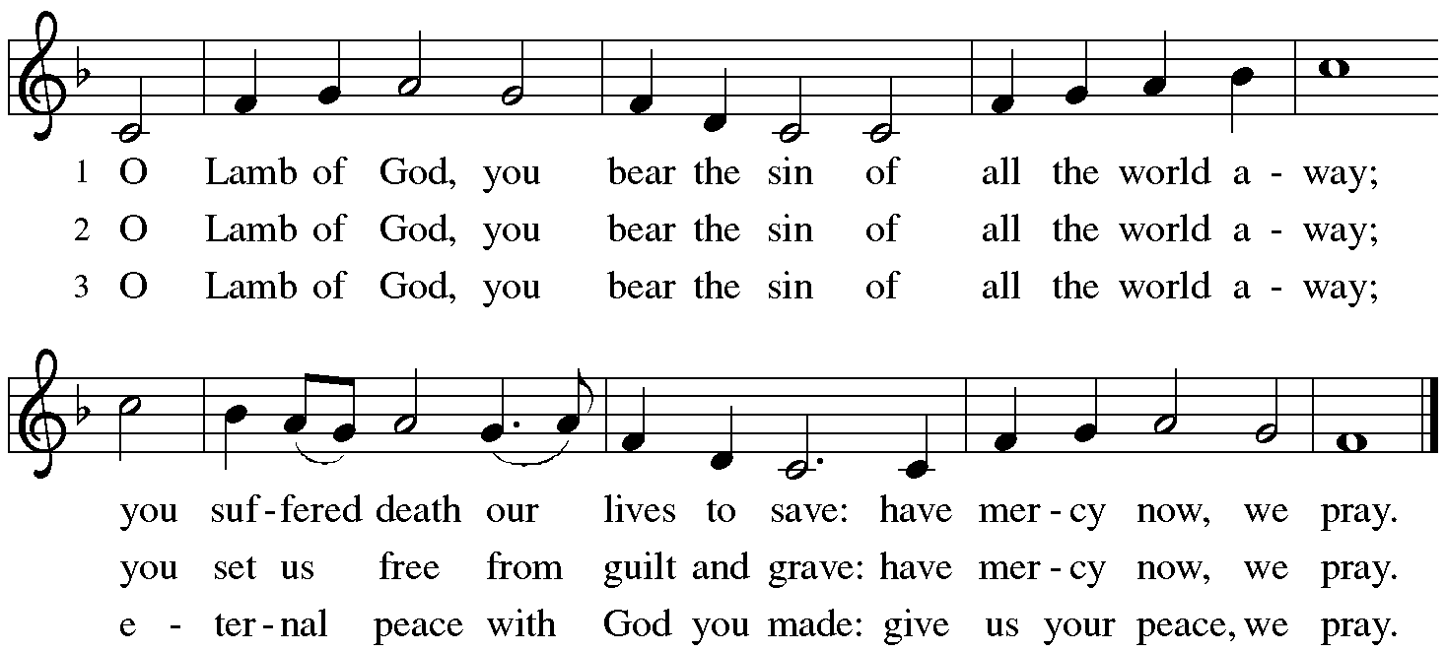

*Dialogue

The Lord be with you.
And also with you.

Lift up your hearts.
We lift them to the Lord.

Let us give thanks to the Lord our God.
It is right to give our thanks and praise.

Table Prayer

Holy God . . . and together with the heavenly host we praise your name.
Amen

Holy, Holy, Holy
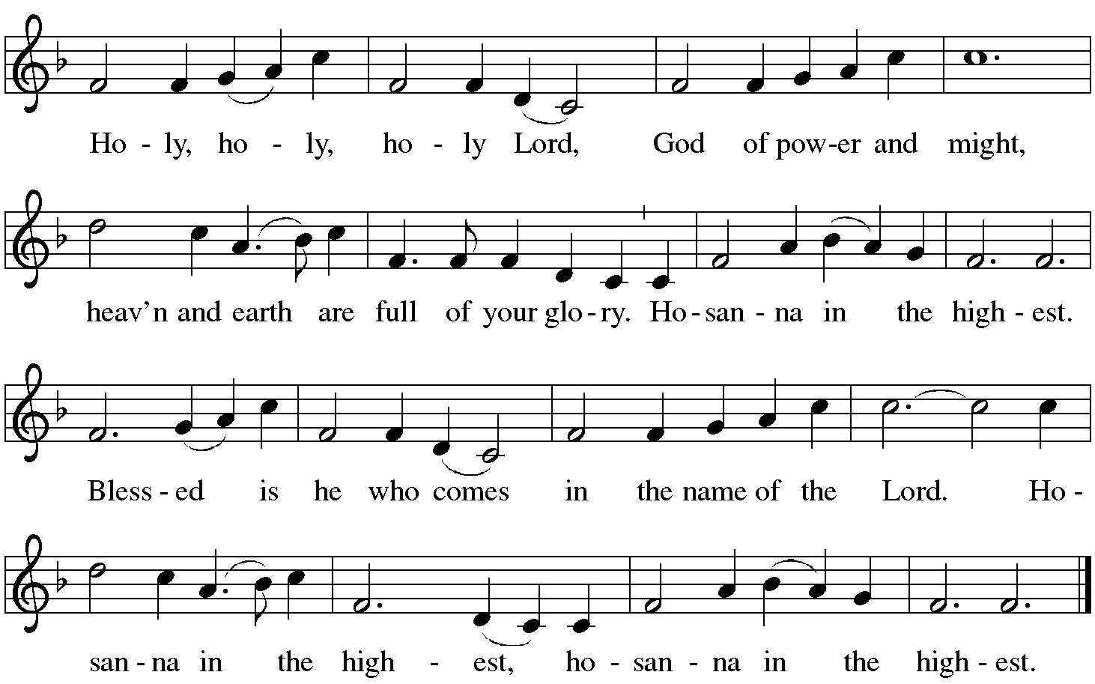

The Words of Institution

In the night…. in your holy Church, both now and forever.
Amen.

Lord's Prayer

As children of your light we pray:

Eternal Spirit, Father and Mother of us all, Holy is your name. Let justice and mercy fill all Creation and let us recognize that every thought and thing belongs to you. Feed us with the bread we need for today. Forgive our sin as we forgive those who sin against us. Stand with us in trial and temptation. Free us from the grip of all that is evil. For you alone are creating our universe, now and forever. Amen.¹

Invitation to Communion

The Distribution Come when you are ready, children are always welcome!

Communion Songs

Now the Silence #460
Rise and Shine You People #665

*Post Communion Blessing

Prayer After Communion

Let us pray.
Nourishing God,
at this table you have refreshed us with holy gifts of food and drink. Strengthen us for service and send us out to embody your good news of liberation and healing for the sake of the world. In the name of Christ, we pray.
Amen.
Please be seated.

Sending
God Blesses Us and Sends Us in Mission to the World.

Our Life Together (pg.14 & 15)

*Blessing

The Spirit of the triune God
☩ bless you with joy,
anoint you with compassion,
and send you in love.

Amen.

Sending Song Draw Us In the Spirit's Tether #470

Dismissal

Go in peace. Live in hope.
Thanks be to God.

Postlude Bob Brown

Copyright © 2024 Augsburg Fortress. All rights reserved. Reprinted by permission under Augsburg Fortress Liturgies Annual License #SAS003548. Expires 9/30/2025 Annual License with Podcasting, OneLicense #A-720902. Expires June 17, 2025.New Revised Standard Version Bible, copyright © 1989, Division of Christian Education of the National Council of the Churches of Christ in the United States of America. Used by permission. All rights reserved. Revised Common Lectionary, Copyright © 1992 Consultation on Common Texts, admin Augsburg Fortress. https://sandhyajha.com/2013/07/01/variations-on-the-lords-prayer/

Second Sunday after Epiphany: January 19, 2025

Assisting Minister: Mallory deForest
Lector: Dannie Gavros

Counters: Shayna Wyasket, Stephanie Wilson
Usher: Casey White
Altar Ministry: Lee Kreutzer
Music Director: Bob Brown
AV Technicians: Duane Lee, Lee Kreutzer
Remote Office Assistant: Brenda Wardle
Presiding Minister: Rev. Christine Higueria-Street

Our Life Together Announcements

Transition Listening Circles - please sign up for one of the listening circles in January. The signup sheets are available after worship from the Transition team members; Dannie, David, Lanea, or Radek. Remember, it is one time, one hour.

Epiphany Bible Study – begins today, January 19th immediately following worship during the coffee hour. Please let Pastor Christine know if you are interested so that we have enough materials for everyone.

Council meets today.

Annual reports need to be to Brenda no later than today, January 19th. So that they can be out two weeks before the annual meeting as our by-laws state.

Senior Food Box Distribution Our distribution of USDA food boxes to seniors in our neighborhood continues with our next distribution set for Wednesday, January 22nd. Boxes are available for those who meet eligibility guidelines and have signed up through the Utah Food Bank. This program is a natural extension of our ongoing partnership with the food bank in which Taborites have volunteered at the Utah Food Bank for over 30 years!

OAKS (Older Adults Knowing Strength) Bible study and luncheon will resume on Tuesday, January 21st at 12 noon. Let Jean know if you plan on attending by Sunday, January 19th. Subsequent OAKS will be on the 3rd Tuesday of each month, all are welcome.

Articles for the February Newsletter need to be sent to Brenda by next Sunday, February 26th. You can email them to her at office@mttaborslc.org

Annual Meeting - Mark your calendars for February 9th immediately following worship.

Family Promise Service Opportunity Mt. Tabor has been presented with an opportunity to provide dinners for Family Promise February 16,17,19, 21, and a brunch on Saturday 22 and again with dinners February 23, 24, 26, 28, and a brunch March 1. All these meals will be provided at the host congregation site of Christ United Methodist Church 2375 E 3300 S. More details at to numbers and special dietary needs will be provided as the dates get
closer. This is a great opportunity to share God’s love with families needing some extra support. If you can provide a meal on any of
those dates, please let me know.
Chris Jensen

Pastor Christine is available by text or email. Her contact information is pastor@mttaborslc.org or 801-215-9208

