2nd Sunday of Christmas


MOUNT TABOR LUTHERAN CHURCH

January 5, 2025


Welcome to our Service

Our mission at Mount Tabor is to be “an inclusive, compassionate faith community living God’s love in the world.” Mount Tabor is a member of the Evangelical Lutheran Church in America and a Reconciling in Christ congregation of the ELCA. This means that all are welcome and affirmed, especially our LGBTQ+ siblings, and that we are connected to the world. We all have a place here at God’s round table just as we are!

If this is your first time here, a special welcome to you! We are mask optional and mask friendly. Please sign the guest register in the narthex (along with your e-mail and cell) so we can be in touch, put on a name tag and join us for refreshments after the service.

Holy Communion is open to all. Children of all ages are invited to receive communion with their parents’ or guardians’ permission. Come when you are ready. Gluten-free bread is available. If you would like a blessing, come to the altar with your arms folded.

Children are welcome at all times in the sanctuary. We are blessed to be part of their faith formation through worship!

Please turn off cell phones in the sanctuary before worship begins.

You may add names to the prayer list by sending a request to Brenda Wardle (office@mttaborslc.org), or Pastor Christine (pastor@mttaborslc.org). Names added to the prayer list will remain there for one month. You may request that they stay on longer or come off sooner by contacting the same people.

Visit our web site at www.mttaborslc.org

Second Sunday of Christmas
January 5, 2025
ELW Service Music
*Please rise as you are able

Greeting & Preparation for Worship

Gathering
The Holy Spirit Calls Us Together as the People of God.

Prelude David Kime

Confession and Absolution
All may make the sign of the cross, the sign that is marked at baptism, as the presiding minister begins.

Blessed be the holy Trinity, ☩ one God,
whose steadfast love is everlasting.
Amen.

Let us confess our sin in the presence of God and of one another.

Silence is kept for reflection.

God-with-us, we confess that we have turned away those seeking shelter, claiming there is no room when we have plenty. We have made power and wealth our idols, while you show us true glory: a baby in a manger. We have overlooked the shepherds, expecting good news in prettier packaging. Too often, we have valued violence instead of your peace. Turn us from our ways to your ways.
Grant us the grace to begin again. Free us from all that keeps us bound, and forgive our sin, through Jesus Christ, who gives himself for us.
Amen.

Hear the good news and rejoice! You are God’s chosen ones, holy and beloved,
☩ forgiven in Christ, and freed to respond in joy.
Amen.

Gathering Song Angels From the Realms of Glory #27

Greeting
The grace of our Lord Jesus Christ, the love of God, and the communion of the
Holy Spirit be with you all.
And also, with you.

Kyrie #157
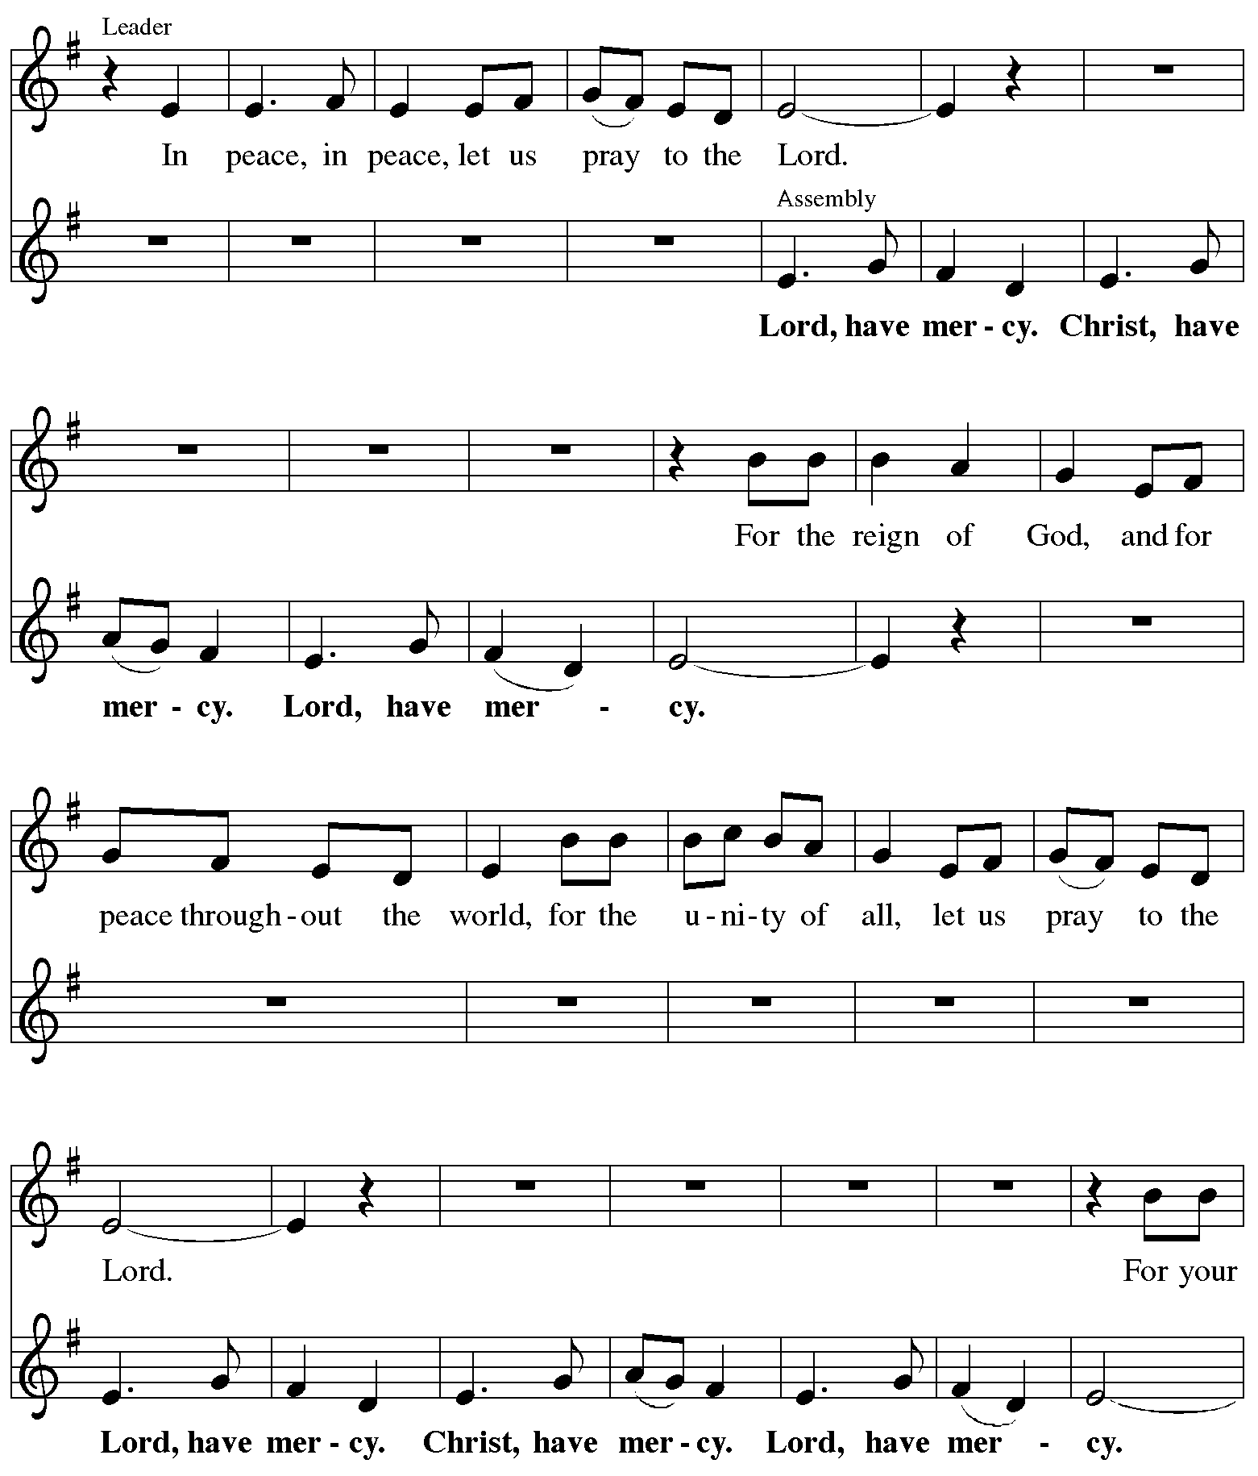
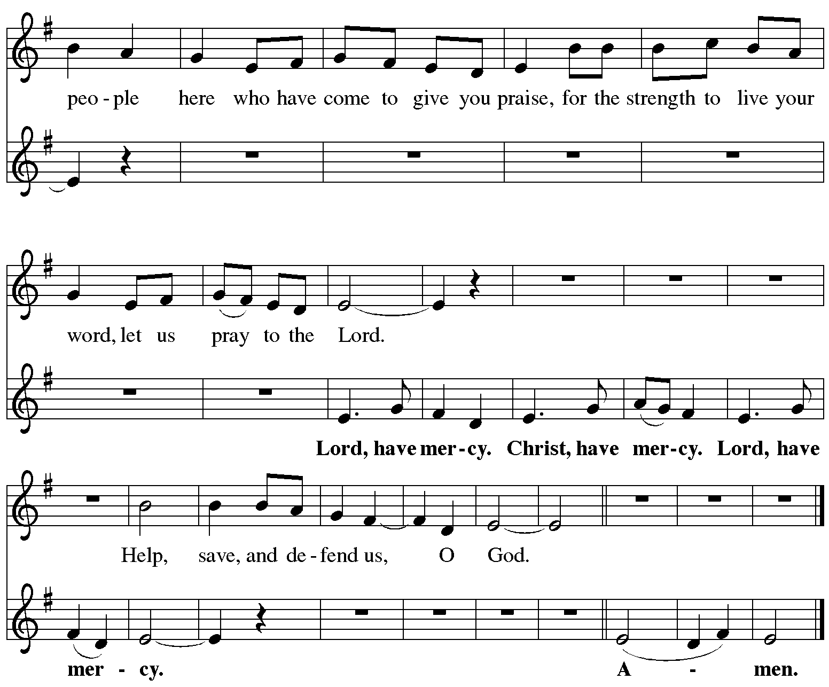

Song of Praise #167
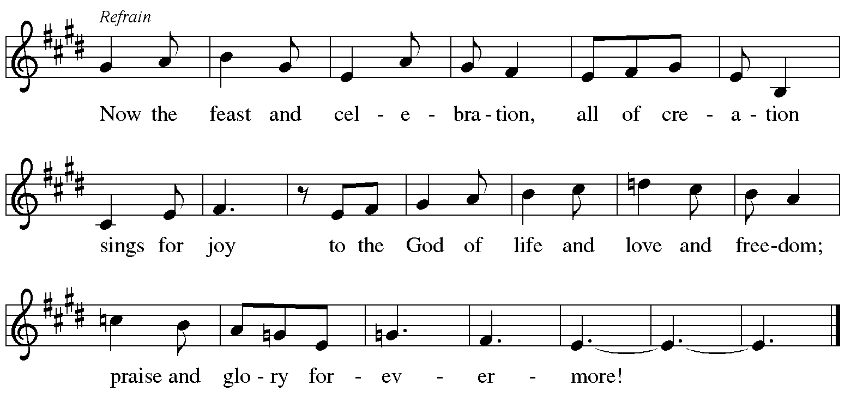

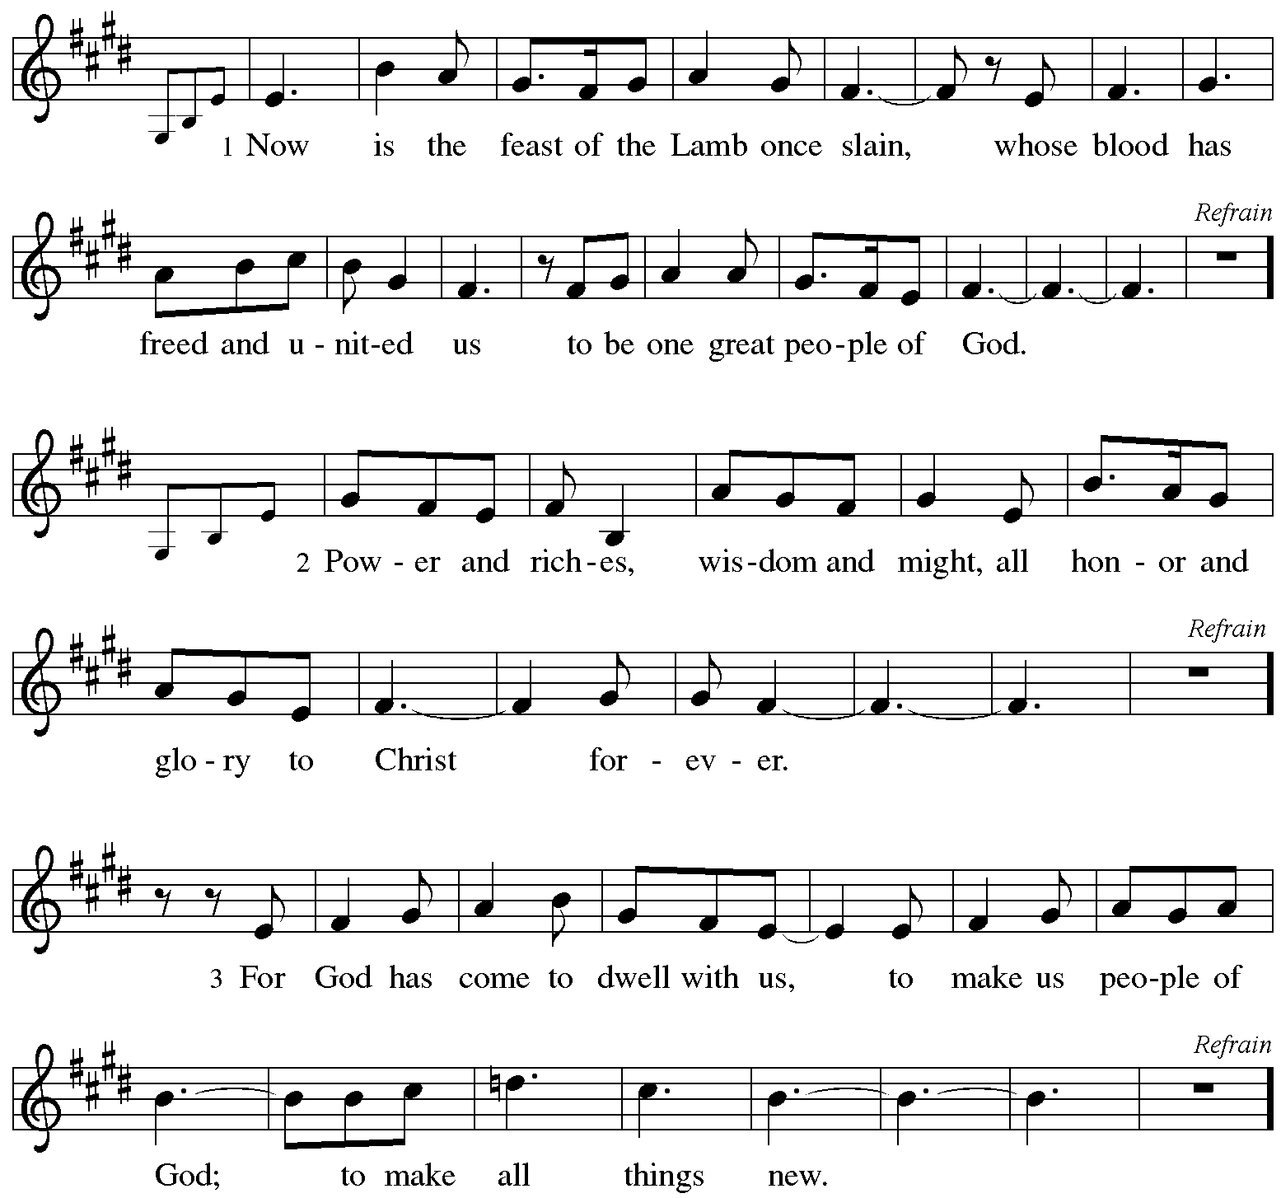

Prayer of the Day
Almighty God, you have filled all the earth with the light of your incarnate Word. By your grace empower us to reflect your light in all that we do, through Jesus Christ, our Savior and Lord, who lives and reigns with you and the Holy Spirit, one God, now and forever.
Amen.
Please be seated.

The Word
God Speaks to Us in Scripture Reading, Preaching and Song

First Reading Jeremiah 31:7-14 ⁷ Thus says the Lord: Sing aloud with gladness for Jacob, and raise shouts for the chief of the nations; proclaim, give praise, and say, “Save, O Lord, your David the north, and gather them from the farthest parts of the earth, among them the blind and the lame, those with child and those in labor, together; a great company; they shall return here. ⁹ With weeping they shall come, and with consolations I will lead them back, I will let them walk by brooks of water, in a straight path in which they shall not stumble; for I have become a father to Israel,
and Ephraim is my firstborn. ¹⁰ Hear the word of the Lord, O nations, and declare it in the coastlands far away; say, “He who scattered Israel will gather him, and will keep him as a shepherd a flock.” ¹¹ For the Lord has ransomed Jacob, and has redeemed him from hands too strong for him.¹² They shall come and sing aloud on the height of Zion, and they shall be radiant over the goodness of the Lord, over the grain, the wine, and the oil, and over the young of the flock and the herd; their life shall become like a watered garden, and they shall never languish again. ¹³ Then shall the young women rejoice in the dance, and the young men and the old shall be merry. I will turn their mourning into joy,
I will comfort them, and give them gladness for sorrow. ¹⁴ I will give the priests their fill of fatness, and my people shall be satisfied with my bounty,

Word of God, word of life.
Thanks be to God.

Special Music David Kime

Second Reading Ephesians 1:3-14
³ Blessed be the God and Father of our Lord Jesus Christ, who has blessed us in Christ with every spiritual blessing in the heavenly places, ⁴ just as he chose us in Christ before the foundation of the world to be holy and blameless before him in love. ⁵ He destined us for adoption as his children through Jesus Christ, according to the good pleasure of his will, ⁶ to the praise of his glorious grace that he freely bestowed on us in the Beloved. ⁷ In him we have redemption through his blood, the forgiveness of our trespasses, according to the riches of his grace ⁸ that he lavished on us. With all wisdom and insight ⁹ he has made known to us the mystery of his will, according to his good pleasure that he set forth in Christ, ¹⁰ as a plan for the fullness of time, to gather up all things in him, things in heaven and things on earth. ¹¹ In Christ we have also obtained an inheritance, having been destined according to the purpose of him who accomplishes all things according to his counsel and will, ¹² so that we, who were the first to set our hope on Christ, might live for the praise of his glory. ¹³ In him you also, when you had heard the word of truth, the gospel of your salvation, and had believed in him, were marked with the seal of the promised Holy Spirit; ¹⁴ this is the pledge of our inheritance toward redemption as God’s own people, to the praise of his glory.

Word of God, word of life.
Thanks be to God.

*Gospel Acclamation - ACS #12
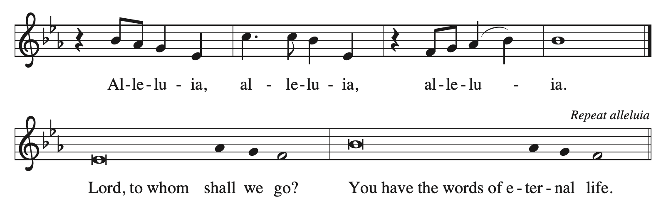

The Gospel

The Holy Gospel according to John
Glory to you, O Lord

. John 10-18
¹⁰ He was in the world, and the world came into being through him; yet the world did not know him. ¹¹ He came to what was his own, and his own people did not accept him. ¹² But to all who received him, who believed in his name, he gave power to become children of God, ¹³ who were born, not of blood or of the will of the flesh or of the will of man, but of God. ¹⁴ And the Word became flesh and lived among us, and we have seen his glory, the glory as of a father’s only son, full of grace and truth. ¹⁵ (John testified to him and cried out, “This was he of whom I said, ‘He who comes after me ranks ahead of me because he was before me.’ ”) ¹⁶ From his fullness we have all received, grace upon grace. ¹⁷ The law indeed was given through Moses; grace and truth came through Jesus Christ. ¹⁸ No one has ever seen God. It is God the only Son, who is close to the Father’s heart, who has made him known.

The Gospel of the Lord.
Praise to you, O Christ.

Message Pastor Christine Higueria-Street
A time of silence follows the sermon for reflection on the message.

*Hymn of the Day Of the Father's Love Begotten #295

The Prayers of the People
Please be seated.

Filled with good news of great joy, let us offer our prayers for the church, the earth, and all people.

After each petition
God of Grace,
receive our prayer.

We remember in prayer. . . . . .
Vicki Lange Doug Kempf
Tonya Aston Ben Roundy
Jan Burke Shannon Wardle
Paul Robinson Brett Wardle
Travis and Nathan Jelsma-Beery Toby Goldsmith
Rosemary Stelz Bruce Palenske
The people of Ukraine, South Sudan, Israel, Gaza and the West Bank

We pray for all those suffering the effects of traumatic events, natural disasters and climate change. We pray for the recovery efforts, the first responders and volunteers who are serving in these areas.

We commend these prayers to you, O God, trusting your grace made known to all, through the Word made flesh, Jesus Christ, our Savior and Lord.
Amen.

Meal
God Feeds Us with the Presence of Jesus Christ.

Sharing our Gifts and Gratitude

We provide several ways of sharing your financial blessings with our congregation. Offering plates are located at the doors of the sanctuary and envelopes can be found in the pews. Simply Giving is an automatic direct-donation method of supporting our life and ministry together. If you would like to enroll in Simply Giving or if you are interested in updating your giving amount, frequency, etc., please contact office@mttaborslc.org with your request. We are grateful and thankful for your support and wonderful generosity. Alternately, feel free to use this QR code to contribute electronically.


Prayer of Gratitude
Let us pray,
God of heaven and earth, from the beginning, you have called forth life, in which you take delight. The trees, the fields, and the seas sing for joy. Bless now these gifts, received from your bounty, that we may join the chorus of creation to tell of your salvation from day to day.
Amen.

Great Thanksgiving
The table is prepared as the assembly sings:

Lamb of God #198
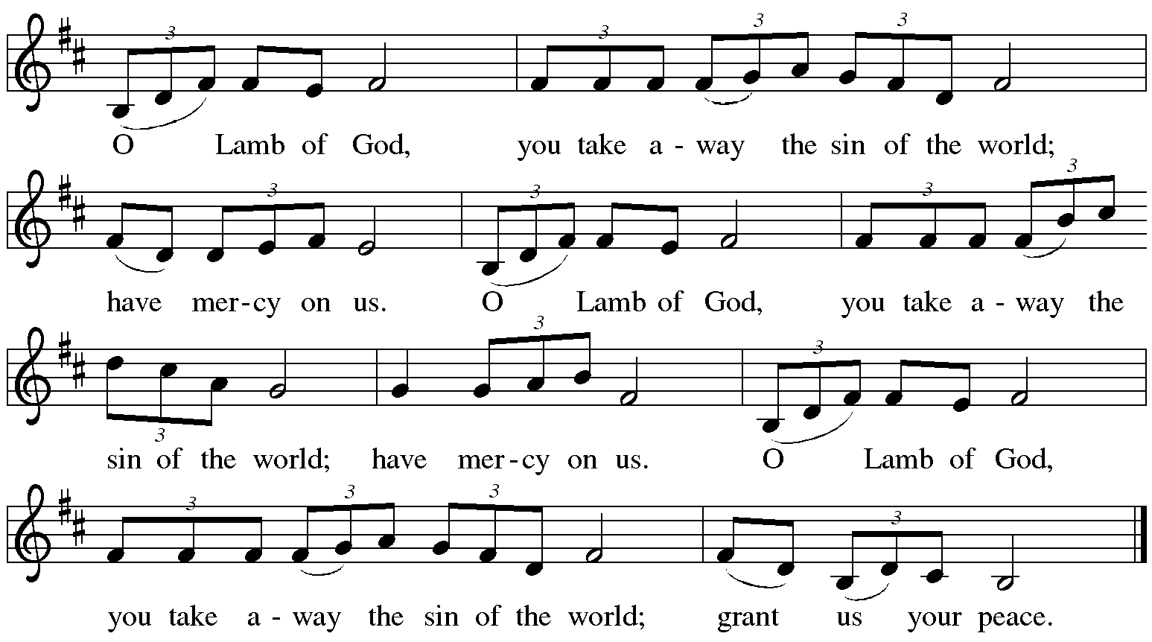

*Dialogue

The Lord be with you.
And also with you.

Lift up your hearts.
We lift them to the Lord.

Let us give thanks to the Lord our God.
It is right to give our thanks and praise.

Table Prayer

Holy God . . . praise at Our Lord Jesus’ birth:
Amen

Holy, Holy, Holy #191
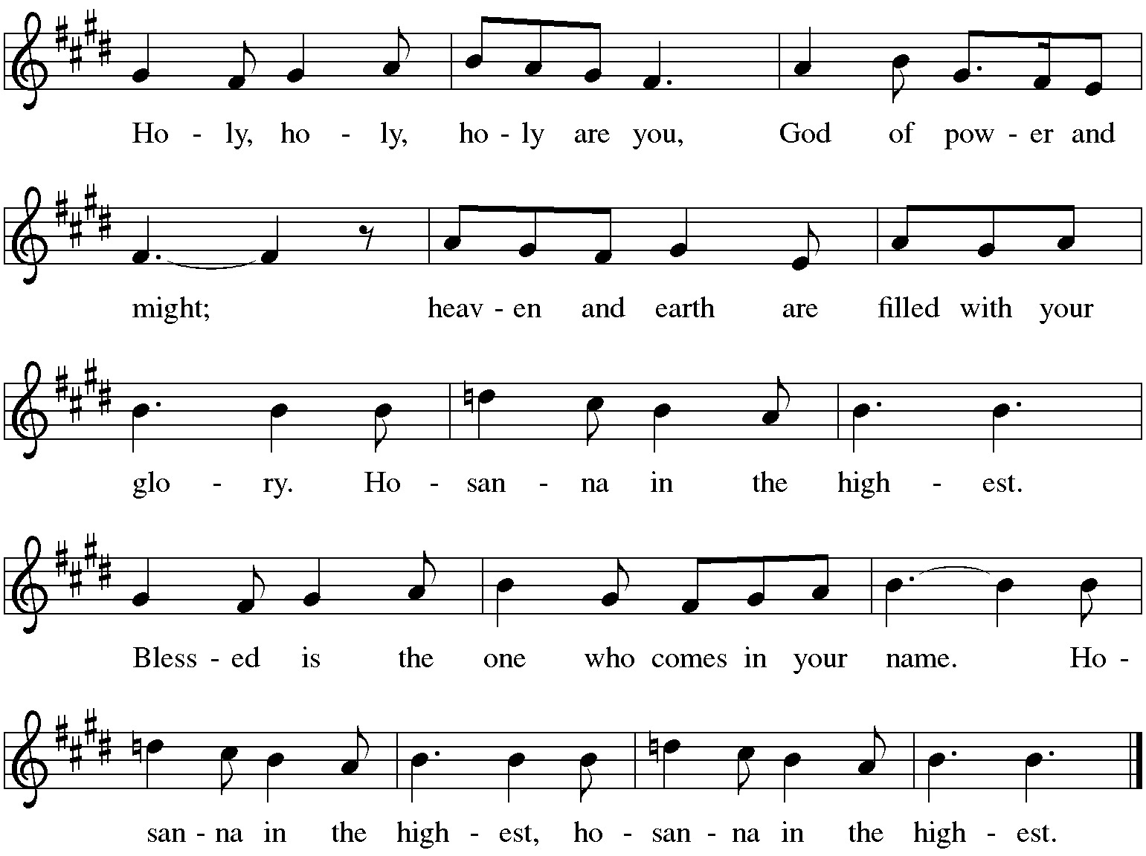

The Words of Institution

In the night…. in your holy Church, both now and forever.
Amen.

Lord's Prayer

We joyfully celebrate God with us and pray:

Our Father in heaven,
hallowed be your name,
your kingdom come,
your will be done,
on earth as in heaven.
Give us today our daily bread.
Forgive us our sins
as we forgive those
who sin against us.
Save us from the time of trial
and deliver us from evil.
For the kingdom, the power,
and the glory are yours,
now and forever. Amen.

Invitation to Communion

The Distribution Come when you are ready, children are always welcome!

Communion Songs

O Come, All Ye Faithful #283
Upon the Midnight Clear #282

*Post Communion Blessing

Prayer After Communion

Let us pray.
Merciful God, we thank you for Jesus, who is our heavenly food. Strengthened by this goodness, send us forth to announce your peace, comfort the afflicted, and share the good news of great joy.
Amen.
Please be seated.

Sending
God Blesses Us and Sends Us in Mission to the World.

Our Life Together (pgs.15&16)

*Blessing

The God of love,
Father, ☩ Son, and Holy Spirit,
lavish you with grace,
illumine your path,
and increase your joy,
today and always.
Amen.

Sending Song Let Our Gladness have No End #291

Dismissal

Go in peace. The Word of God dwells in you richly.
Thanks be to God.

Postlude David Kime

Copyright © 2024 Augsburg Fortress. All rights reserved. Reprinted by permission under Augsburg Fortress Liturgies Annual License #SAS003548. Expires 9/30/2025 Annual License with Podcasting, OneLicense #A-720902. Expires June 17, 2025.New Revised Standard Version Bible, copyright © 1989, Division of Christian Education of the National Council of the Churches of Christ in the United States of America. Used by permission. All rights reserved. Revised Common Lectionary, Copyright © 1992 Consultation on Common Texts, admin Augsburg Fortress.

January 5, 2025 Second Sunday of Christmas

Assisting Minister: Lawrence Allred
Lector: Chris Jensen

Counters: Virginia Hancock, Dave Warren
Usher: Sarah Lange
Altar Ministry:
Music Director: Bob Brown
AV Technicians: Duane Lee, Lee Kreutzer
Remote Office Assistant: Brenda Wardle
Presiding Minister: Rev. Christine Higueria-Street

sunds

Our Life Together Announcements

Transition Listening Circles - please sign up for one of the listening circles in January. The signup sheets are available after worship from the Transition team members; Dannie, Lanea, or Radek. Remember, it is one time, one hour.

Curious About Joy – A Women’s Christmas Retreat Saturday, January 11, 2025 10 a.m. – 1 p.m.at Mt. Tabor Lutheran Church. The registration fee for this retreat is $25. Scholarships are available. Please let Pastor DanaLee know if you are in need of one. Please register and reserve your spot by e-mailing DanaLee and letting her know you will be attending. Include your name, phone number and congregation. Her e-mail address is sagehillwisdom@gmail.com. For more information please see our website at www.mttaborslc.org or talk to Jean Stephenson.

"Dinner At Vinny's service opportunity is Tuesday, January 14th from 4:30-6:30pm at the St Vincent DePaul Dining Hall at the Weigand Center downtown. Come and share Tabor’s gracious and loving hospitality with our hungry neighbors living on the streets. We always have room for more volunteers! Please see Casey White if you have any questions.

Epiphany Bible Study - will begin on Sunday, January 19th immediately following worship during the coffee hour. Please let Pastor Christine know if you are interested so that we have enough materials for everyone.

Annual reports need to be to Brenda no later than January 19th. So that they can be out two weeks before the annual meeting as our by-laws state.

Senior Food Box Distribution Our distribution of USDA food boxes to seniors in our neighborhood continues with our next distribution set for Wednesday, January 22nd. Boxes are available for those who meet eligibility guidelines and have signed up through the Utah Food Bank. This program is a natural extension of our ongoing partnership with the food bank in which Taborites have volunteered at the Utah Food Bank for over 30 years! Our distribution is growing and we expect even more clients in November - stay tuned!

OAKS (Older Adults Knowing Strength) bible study and luncheon will resume on Tuesday, January 21st at 12 noon. Let Jean know if you plan on attending by Sunday, January 19th. Subsequent OAKS will be on the 3rd Tuesday of each month, all are welcome.

Annual Meeting - Mark your calendars for February 9th immediately following worship.

Pastor Christine is available by text or email. Her contact information is pastor@mttaborslc.org or 801-215-9208

