Reconciling in Christ Sunday
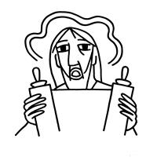

MOUNT TABOR LUTHERAN CHURCH

January 26, 2025


Welcome to our Service

Our mission at Mount Tabor is to be “an inclusive, compassionate faith community living God’s love in the world.” Mount Tabor is a member of the Evangelical Lutheran Church in America and a Reconciling in Christ congregation of the ELCA. This means that all are welcome and affirmed, especially our LGBTQ+ siblings, and that we are connected to the world. We all have a place here at God’s round table just as we are!

If this is your first time here, a special welcome to you! We are mask optional and mask friendly. Please sign the guest register in the narthex (along with your e-mail and cell) so we can be in touch, put on a name tag and join us for refreshments after the service.

Holy Communion is open to all. Children of all ages are invited to receive communion with their parents’ or guardians’ permission. Come when you are ready. Gluten-free bread is available. If you would like a blessing, come to the altar with your arms folded.

Children are welcome at all times in the sanctuary. We are blessed to be part of their faith formation through worship!

Please turn off cell phones in the sanctuary before worship begins.

You may add names to the prayer list by sending a request to Brenda Wardle (office@mttaborslc.org), or Pastor Christine (pastor@mttaborslc.org). Names added to the prayer list will remain there for one month. You may request that they stay on longer or come off sooner by contacting the same people.

Visit our web site at www.mttaborslc.org

Reconciling in Christ Sunday
ELW Setting Ten
*Please rise as you are able

Greeting & Preparation for Worship

Gathering
The Holy Spirit Calls Us Together as the People of God.

*Affirmation Litany of Welcome and Inclusion
As a Reconciling in Christ congregation, we recommit ourselves today to continue the work of radical welcome and inclusion of all people here at Mt. Tabor Lutheran Church.

For Our Church,

May we practice what we preach and, with open arms, welcome those who identify as members of the LGBTQIA+ community. May those in positions of power within the church remember that Jesus welcomed all to the table without discrimination.

For Our World,

May we rejoice in the diversity that makes up the human race. That we may find ourselves curious instead of condemning those who are different from us, and that we rejoice in the many ways God’s love flows through each of us.

For the families and friends who have lost loved ones due to violence and discrimination towards queer persons.

May God’s love and peace be a balm to their aching hearts, and may they feel their loved ones close in spirit.

For those who ever wondered if they were truly made in the image and likeness of God because of their sexual orientation or gender identity.

May they know they are fearfully and wonderfully made in God’s loving image.

For those in the LGBTQIA+ community who have felt ostracized because the Word of God has been turned into a weapon and a tool of oppression.
May God break through the barriers that have led to harmful interpretations.

We ask that God hear the sound of our pleading and sustain us in our work in recognizing and affirming the LGBTQIA+ community.

May we hold together the desperation we feel and the hope for which we long.
Amen.
Please be seated.

Prelude Bob Brown

*Confession and Absolution
All may make the sign of the cross, the sign that is marked at baptism, as the presiding minister begins.

Blessed be the holy Trinity, ☩ one God,
our creator,
our protector,
our wellspring of life.
Amen.

Trusting that God receives our words and the meditations of our hearts, let us confess our sin.

Silence is kept for reflection.

Merciful God, you speak blessing and compassion into the world. Forgive us for the ways we act with judgment, cruelty, or indifference. We ignore the needs of our neighbors; we resist your call to oppose injustice; we give in to scarcity and fear; we assume the worst about one another. Cleanse us from our faults and release us from their grasp. Show us your loving kindness. Restore our hearts and repair your world, that we may live in Christ’s ways.
Amen.

God proclaims these words of assurance: “Do not fear, for I have redeemed you. I have called you by name. You are mine.” In ☩ Christ, you are forgiven. In the Spirit, you are made free. Refreshed by the waters of mercy, live anew as beloved children of God.
Amen.

Gathering Song What is this Place #524

Greeting
The grace of our Lord Jesus Christ, the love of God, and the communion of the
Holy Spirit be with you all.
And also, with you.

Kyrie
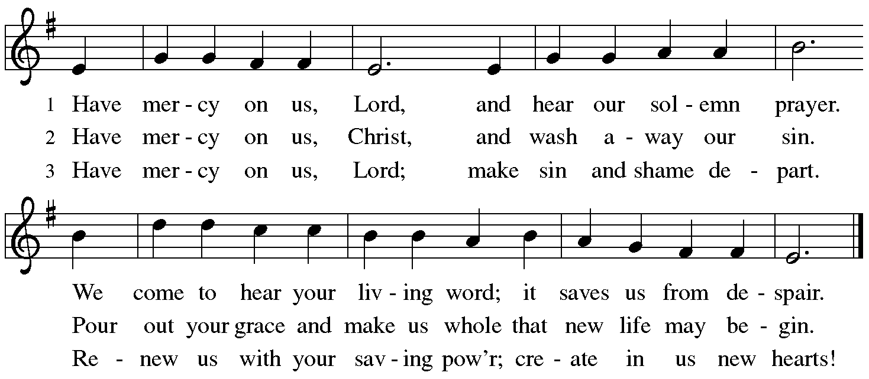

Song of Praise
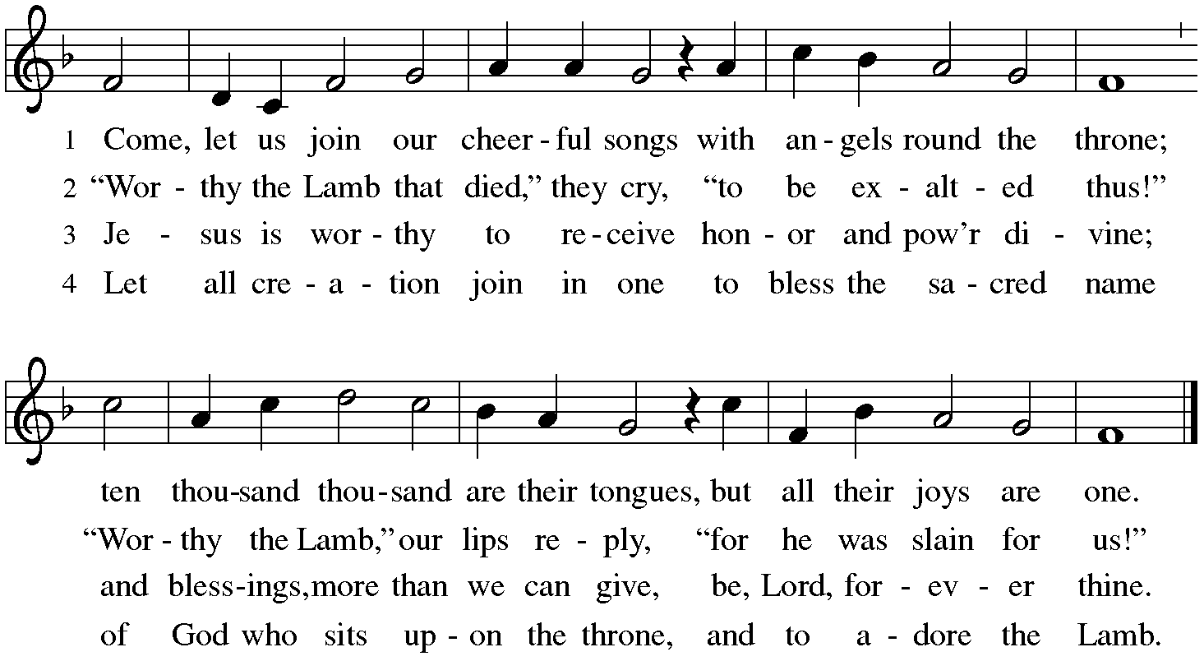

Prayer of the Day
Holy God, your Word teaches us, calls us, ad shapes us, that we will become the wisdom of God and the body of Christ for others. On this Reconciling in Christ Sunday, may your word turn us toward what is good and holy and just, that all your beloveds of all sexual ad romantic orientations, identities, and expressions will know we are seen, known, and loved by you. May the example of Jesus continue to create words and actions of courage in the work and ministry of anti-racism.
Amen.
Please be seated.

The Word
God Speaks to Us in Scripture Reading, Preaching and Song

First Reading Nehemiah 8:1-3, 5-6, 8-10

¹ All the people [of Israel] gathered together into the square before the Water Gate. They told the scribe Ezra to bring the book of the law of Moses, which the Lord had given to Israel. ² Accordingly, the priest Ezra brought the law before the assembly, both men and women and all who could hear with understanding. This was on the first day of the seventh month. ³ He read from it facing the square before the Water Gate from early morning until midday, in the presence of the men and the women and those who could understand; and the ears of all the people were attentive to the book of the law. ⁵ And Ezra opened the book in the sight of all the people, for he was standing above all the people; and when he opened it, all the people stood up. ⁶ Then Ezra blessed the Lord, the great God, and all the people answered, “Amen, Amen,” lifting up their hands. Then they bowed their heads and worshiped the Lord with their faces to the ground. ⁸ So they read from the book, from the law of God, with interpretation. They gave the sense, so that the people understood the reading.
⁹ And Nehemiah, who was the governor, and Ezra the priest and scribe, and the Levites who taught the people said to all the people, “This day is holy to the Lord your God; do not mourn or weep.” For all the people wept when they heard the words of the law. ¹⁰ Then he said to them, “Go your way, eat the fat and drink sweet wine and send portions of them to those for whom nothing is prepared, for this day is holy to our Lord; and do not be grieved, for the joy of the Lord is your strength.”

Word of God, word of life.
Thanks be to God.

Special Music Lift Thine Eyes Mendelssohn

Jenny Jensen, Mallory deForest, Stephanie Wilson, Lee Kreutzer, Deb Elstad
Vocalists

Second Reading 1 Corinthians 12:12-31a

¹² For just as the body is one and has many members, and all the members of the body, though many, are one body, so it is with Christ. ¹³ For in the one Spirit we were all baptized into one body—Jews or Greeks, slaves or free—and we were all made to drink of one Spirit. ¹⁴ Indeed, the body does not consist of one member but of many. ¹⁵ If the foot would say, “Because I am not a hand, I do not belong to the body,” that would not make it any less a part of the body. ¹⁶ And if the ear would say, “Because I am not an eye, I do not belong to the body,” that would not make it any less a part of the body. ¹⁷ If the whole body were an eye, where would the hearing be? If the whole body were hearing, where would the sense of smell be? ¹⁸ But as it is, God arranged the members in the body, each one of them, as he chose. ¹⁹ If all were a single member, where would the body be? ²⁰ As it is, there are many members, yet one body. ²¹ The eye cannot say to the hand, “I have no need of you,” nor again the head to the feet, “I have no need of you.” ²² On the contrary, the members of the body that seem to be weaker are indispensable, ²³ and those members of the body that we think less honorable we clothe with greater honor, and our less respectable members are treated with greater respect; ²⁴ whereas our more respectable members do not need this. But God has so arranged the body, giving the greater honor to the inferior member, ²⁵ that there may be no dissension within the body, but the members may have the same care for one another. ²⁶ If one member suffers, all suffer together with it; if one member is honored, all rejoice together with it. ²⁷ Now you are the body of Christ and individually members of it. ²⁸ And God has appointed in the church first apostles, second prophets, third teachers; then deeds of power, then gifts of healing, forms of assistance, forms of leadership, various kinds of tongues. ²⁹ Are all apostles? Are all prophets? Are all teachers? Do all work miracles? ³⁰ Do all possess gifts of healing? Do all speak in tongues? Do all interpret? ^{31a} But strive for the greater gifts.

Word of God, word of life.
Thanks be to God.

*Gospel Acclamation

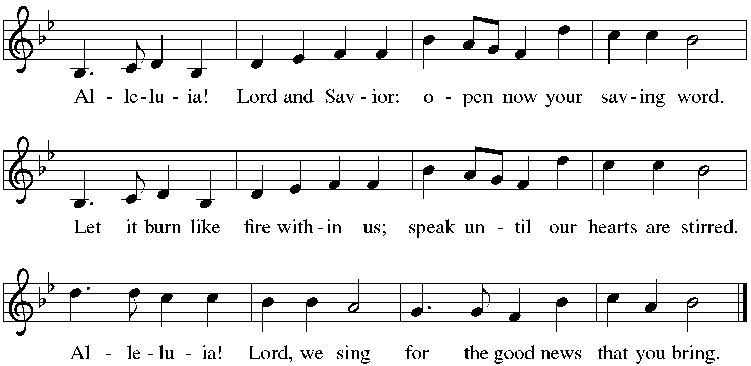

The Gospel

The Holy Gospel according to Luke..
Glory to you, O Lord.

. Luke 4:14-21
¹⁶ When he came to Nazareth, where he had been brought up, he went to the synagogue on the sabbath day, as was his custom. He stood up to read, ¹⁷ and the scroll of the prophet Isaiah was given to him. He unrolled the scroll and found the place where it was written:¹⁸ “The Spirit of the Lord is upon me, because he has anointed me to bring good news to the poor he has sent me to proclaim release to the captives and recovery of sight to the blind, to let the oppressed go free, ¹⁹ to proclaim the year of the Lord’s favor.” ²⁰ And he rolled up the scroll, gave it back to the attendant, and sat down. The eyes of all in the synagogue were fixed on him. ²¹ Then he began to say to them, “Today this scripture has been fulfilled in your hearing.”

The Gospel of the Lord.
Praise to you, O Christ.

Message Pastor Christine Higueria-Street
A time of silence follows the sermon for reflection on the message.

*Hymn of the Day Lord Speak to Us, That We May Speak #676

Affirmation of Faith
God desires full life for all. As a church we recognize that beloved children whose sexual or romantic orientation, gender identity, or gender expression do not follow the patterns of sexism and patriarchy are too often restricted from realizing abundant life. This church names as sin the social forces that silence, control, or devalue people on the basis on sexual or romantic orientation, gender identity, or gender expression. We affirm all people are created in God’s image, and we reject any power, privilege, or prejudice that undermines our community and disrupts joy, gladness, relationships, and flourishing life for all people.

I invite you to profess your faith, renouncing the forces of evil and the power of sin. Do you renounce the powers of racism, sexism, queerphobia, homophobia, transphobia, biphobia, and ablism?

We renounce them.

Do you renounce the systems of oppression that harm God’s children?

We renounce them.

Do you renounce the sins of silence that draw one away from God and neighbor?

We renounce them.

Do you believe in God the Creator?

We believe in you, O God, who spoke all life into being, author of heaven and earth, architect of time, quilter of the cosmos. You shape our bodies from the dust of the ground, and by your breath we are given life.

Do you believe in Jesus Christ?

We believe in you, O God, who became incarnate in Christ Jesus, the Word made flesh, truly divine and truly human. You lived among us to reveal your justice, died among us to break the bonds of sin and death, and were raised among us to bring abundant life.

Do you believe in God the Holy Spirit?

We believe in you, O God, who transforms us by the Holy Spirit, draws us into community, moves us to action, and inspires us to hope against hope. You breathe new life into a fallen world and equip us to proclaim the good news of resurrecting love. All thanks and praise to you, O God, our beginning and our end.
Amen.
Please be seated.

The Prayers of the People

Trusting in the liberating and reconciling love of God, let us pray for all people and all creation.

After each petition
Merciful God,
receive our prayer.

We remember in prayer. . . . . .
Vicki Lange Doug Kempf
Tonya Aston Ben Roundy
Jan Burke Toby Goldsmith
Paul Robinson Mike Street
Travis and Nathan Jelsma-Beery Dannie Gavros
Rosemary Stelz Scott Larrabee

We pray for all those suffering the effects of traumatic events, natural disasters and climate change. We pray for the recovery efforts, the first responders and volunteers who are serving in these areas.

We entrust these our prayers, spoken and silent, and our sighs to deep for words, to your abundant mercy, through Christ our Lord.
Amen.

Sharing the Peace
The peace of Christ be with you always.
And also with you.
Let us greet one another with a sign of this spirit-filled peace, respecting the boundaries and honoring the consent of our neighbors.

Meal
God Feeds Us with the Presence of Jesus Christ.

Sharing our Gifts and Gratitude

We provide several ways of sharing your financial blessings with our congregation. Offering plates are located at the doors of the sanctuary and envelopes can be found in the pews. Simply Giving is an automatic direct-donation method of supporting our life and ministry together. If you would like to enroll in Simply Giving or if you are interested in updating your giving amount, frequency, etc., please contact office@mttaborslc.org with your request. We are grateful and thankful for your support and wonderful generosity. Alternately, feel free to use this QR code to contribute electronically.
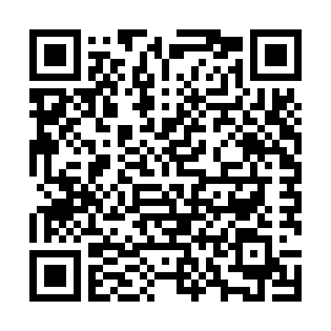

Prayer of Gratitude
Let us pray,
Generous God, we give you praise! You liberate us from sin and death by the abundance at this table. Multiply these gifts and fill us with your spirit, so that we may embody Christ and enflesh your radical freedom.
Amen.

Great Thanksgiving
The table is prepared as the assembly sings:

Lamb of God
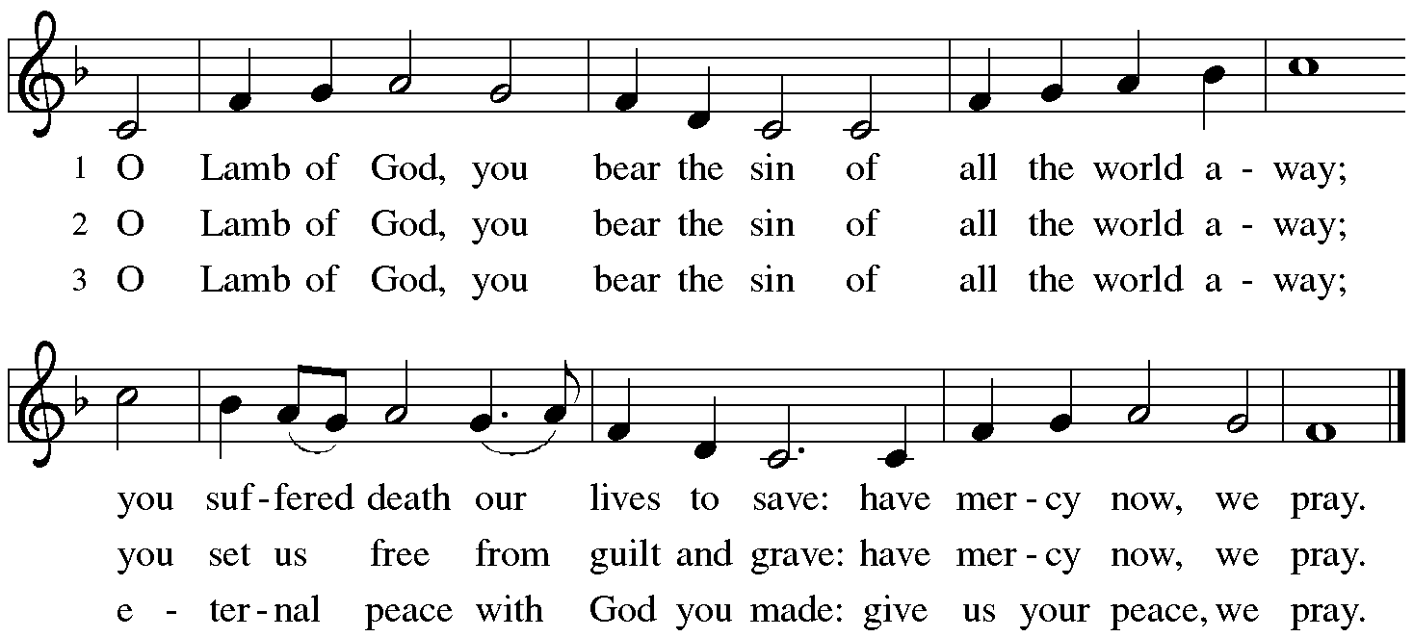

*Dialogue

The Lord be with you.
And also with you.

Lift up your hearts.
We lift them to the Lord.

Let us give thanks to the Lord our God.
It is right to give our thanks and praise.

Table Prayer

Holy God . . . and together with the heavenly host we praise your name.
Amen

Holy, Holy, Holy
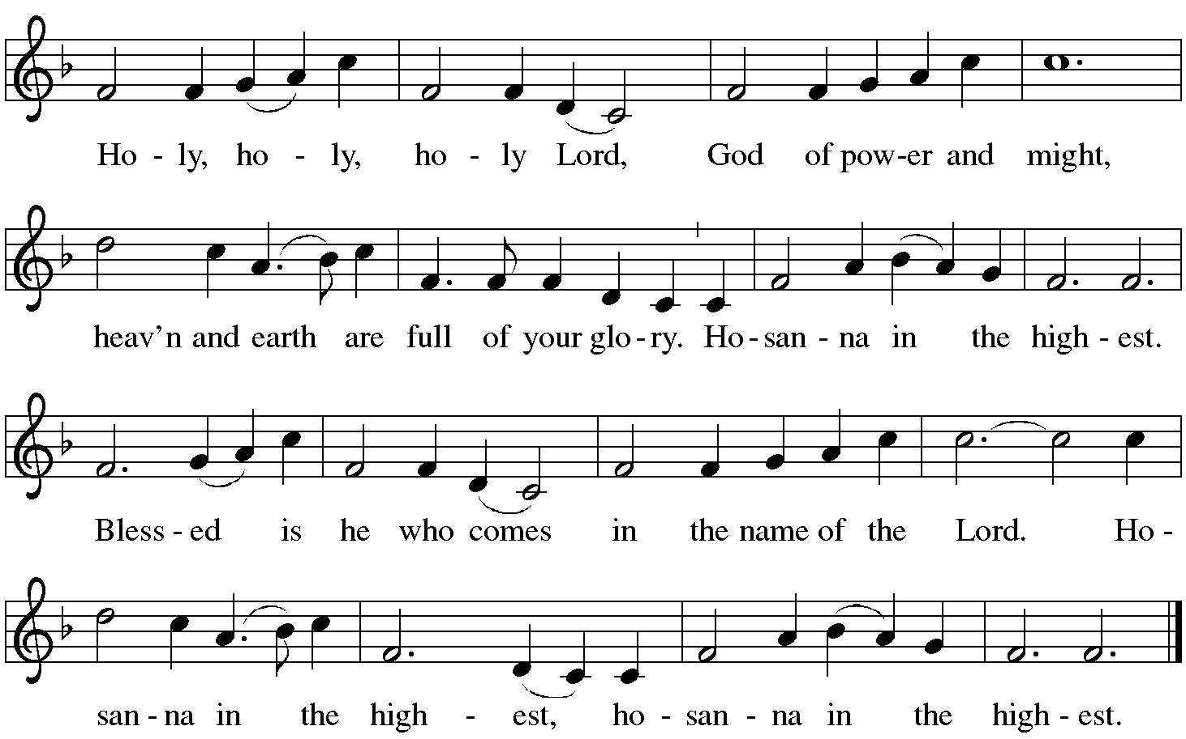

The Words of Institution

In the night…. in your holy Church, both now and forever.
Amen.

Lord's Prayer

As children of your light, we pray:

Eternal Spirit, Father and Mother of us all, Holy is your name. Let justice and mercy fill all Creation and let us recognize that every thought and thing belongs to you. Feed us with the bread we need for today. Forgive our sin as we forgive those who sin against us. Stand with us in trial and temptation. Free us from the grip of all that is evil. For you alone are creating our universe, now and forever. Amen.

Invitation to Communion

The Distribution Come when you are ready, children are always welcome!

Communion Songs

All Who Hunger, Gather Gladly #461
Rise and Shine You People #665

*Post Communion Blessing

Prayer After Communion

Let us pray.
Nourishing God,
at this table you have refreshed us with holy gifts of food and drink. Strengthen us for service and send us out to embody your good news of liberation and healing for the sake of the world. In the name of Christ, we pray.
Amen.
Please be seated.

Sending
God Blesses Us and Sends Us in Mission to the World.

Our Life Together (pg.19)

*Blessing

Let nothing disturb you. Let nothing make you afraid. All things are passing. God alone never changes. Patience gains all things. If you have God you will want for nothing. God alone suffices. (Teresa of Avila)

☩ May the blessing of God, Holy One and Holy Three, be with us today and every day, building us into a resilient community that practices justice and radical inclusion.
Amen.

Sending Song The Lord Now Sends Us Forth #538

Dismissal
Go in peace to practice resilient justice.
Thanks be to God.

Postlude Bob Brown

Copyright © 2024 Augsburg Fortress. All rights reserved. Reprinted by permission under Augsburg Fortress Liturgies Annual License #SAS003548. Expires 9/30/2025 Annual License with Podcasting, OneLicense #A-720902. Expires June 17, 2025.New Revised Standard Version Bible, copyright © 1989, Division of Christian Education of the National Council of the Churches of Christ in the United States of America. Used by permission. All rights reserved. Revised Common Lectionary, Copyright © 1992 Consultation on Common Texts, admin Augsburg Fortress. The Lord’s Prayer: https://sandhyajha.com/2013/07/01/variations-on-the-lords-prayer/ Litany of Welcome and Inclusion: Adapted from prayers by Sr. Jane Aseltyne, IHM, July 23, 2023 https://www.newwaysministry.org/2023/07/23/prayers-of-lament-and-hope-for-lgbtq-people/ Prayers, Affirmation of Faith, Peace, Blessing and Dismissal adapted from Reconciling Works Reconciling in Christ Sunday 2025 Resilient Community.

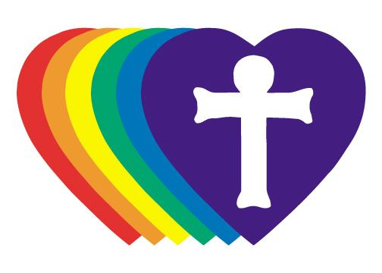

Mt Tabor Lutheran Church RIC Statement of Welcome and Inclusion

We acknowledge that we gather and minister on the ancestral lands of the Shoshone, Paiute, Goshute, and Ute peoples.

We welcome all who seek God’s love and grace. Our unity is rooted in Christ, called by Jesus to love God and one another. We are committed to practicing radical hospitality and serving all without conditions. Mount Tabor is dedicated to celebrating the dignity of every person, particularly those in the LGBTQIA+ community who express their gender identity, gender expression, and sexual orientation in ways that challenge societal and local norms. We also affirm our welcome of Black, Indigenous, and People of Color, as well as white allies committed to justice and equity.

We affirm the sacred worth of all, including those who struggle with addiction, mental or physical health challenges, imprisonment, socio-economic circumstances, or any other circumstance that divides us. We commit ourselves to the holy work of anti-racism, social and economic justice, and care for the environment. Together, we pledge to live as a reconciling people—on the path to the cross and in our outreach to the world—striving to embody God's love and justice in all that we do.

Updated 11/2024

Reconciling in Christ Sunday: January 26, 2025

Assisting Minister: Casey White
Lector: Virginia Hancock

Counters: Stephanie Wilson
Usher: Leslie Carey
Altar Ministry: Lanea Brown
Music Director: Bob Brown
AV Technicians: Duane Lee, Lee Kreutzer
Remote Office Assistant: Brenda Wardle
Presiding Minister: Rev. Christine Higueria-Street

Our Life Together Announcements

Utah Food Bank We will be sorting food at the Utah Food Bank Saturday, February 1st from 10am to Noon.

Worship and Music Team will be meeting after worship on Sunday, February 2nd.

Transition Listening Circles - please sign up for one of the listening circles in January. The signup sheets are available after worship from the Transition team members; Dannie, David, Lanea, or Radek. Remember, it is one time, one hour.

Epiphany Bible Study – continues today, immediately following worship during the coffee hour. Please let Pastor Christine know if you are interested so that we have enough materials for everyone.

OAKS (Older Adults Knowing Strength) Bible study and luncheon will resume on Tuesday, February18th at 12 noon. Let Alvina Wall know if you plan on attending by Sunday, February 16th. Subsequent OAKS will be on the 3rd Tuesday of each month, all are welcome.

Annual Meeting - Mark your calendars for February 9th immediately following worship.

Family Promise Service Opportunity for Mt. Tabor has been presented with an opportunity to provide dinners for Family Promise February 16, 17, 19, 21, and a brunch on Saturday 22 and again with dinners February 23, 24, 26, 28, and a brunch March 1. All these meals will be provided at the host congregation site of Christ United Methodist Church 2375 E 3300 S. More details as to numbers and special dietary needs will be provided as the dates get
closer. This is a great opportunity to share God’s love with families needing some extra support. If you can provide a meal on any of
those dates, please let me know. Chris Jensen

Pastor Christine is available by text or email. Her contact information is pastor@mttaborslc.org or 801-215-9208

